Development Diary

citypoint room hire

Jamie gallagher

2026

**Development Documentation**

**Development Diary**

# Version System

0.X.X – This shows that a major change has been implemented.

X.0.X – This shows that a few changes have been made.

X.X.0 – This shows that a small change or changes have been made.

Contents

Version System 1

Version 0.0.0 – Creating and setting up the project with ASP.NET 9.0 MVC (Model View Controller) 1

Version 0.0.1 – Creating all models required 4

0.1.1 – Adding Google Authentication 10

Version 0.2.1 – Creating the Room Booking System and allows rooms to be purchased 13

Version 0.2.2 – Seeding data for development, so the website is usable on startup from any location, helps with development and makes it so data doesn’t need manual loading 18

Version 0.2.3 – User Roles 23

Version 0.3.3 – Stylizing nav bar, footer and landing page. 24

Version 0.4.3 – Stylizing the rooms (room booking) and booking policy page 28

Version 0.5.3 - Sylizing the Contact Us and Accessibility Page 32

Version 0.6.3 – Ensuring Security throughout the website 35

Version 0.6.4 – Adding the admin dashboard to the navbar of the website 36

Version 0.7.4 – Admin Controller 36

Version 1.7.4 – Staff Dashboard 40

Version 1.8.4 – Accessibility Settings 44

Version 1.9.4 Booking Overlapping 52

Version 1.9.5 – Non existent booking dates 54

# Version 0.0.0 – Creating and setting up the project with ASP.NET 9.0 MVC (Model View Controller)

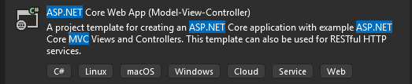

Picking the correct project template, we are going to make us of ASP.NET Core Web App MVC (Model View Controller) due to the great foundation it provides to build on. We give it the project name CPRH (CityPoint Room Hire). We select the framework .NET 9.0 due to the fact it is the latest version with long-term support on Visual Studio 2022 as of currently, and we select individual accounts to register and login in, which creates all the user database for us and all the functionality, being able to edit and customize it for our needs.

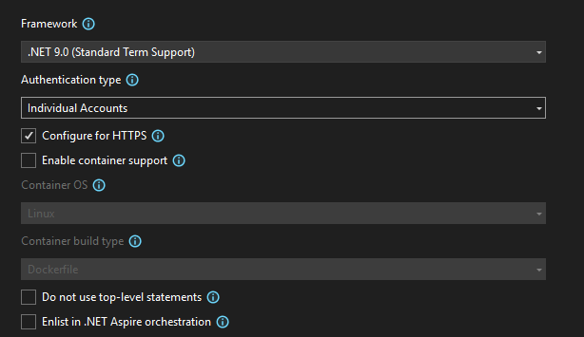

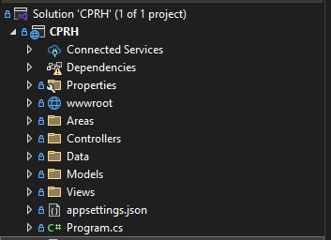

Then by pressing the Create button, the project is created, we first install base packages (typically to version 9.0.12 as it is the latest for .NET 9.0) to allow us to have extra functionality, and so that we wont have to add new migrations later on in the project,



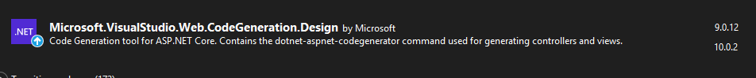

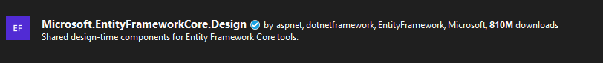

Now we run the website to see if everything works as expected.

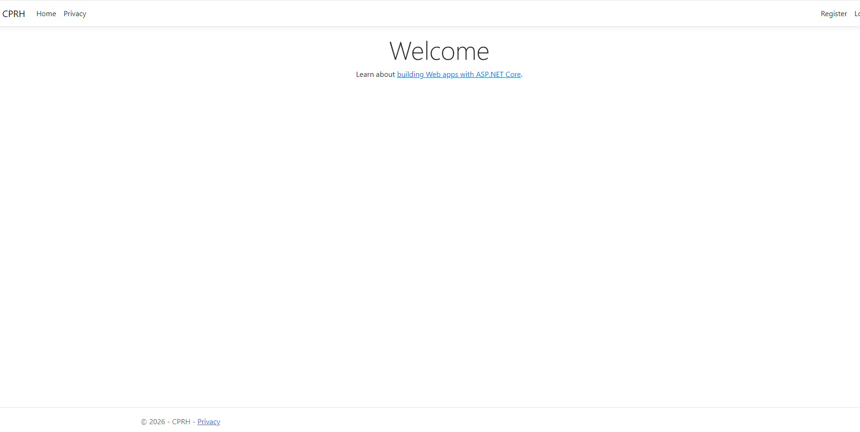

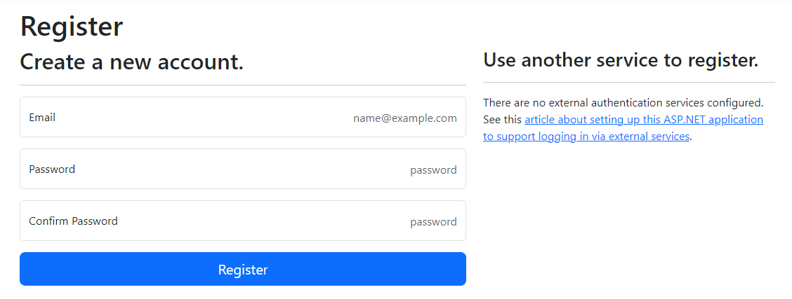

Main views seem to load as expected, however, although it may seem like it is working, upon attempting to register, I am faced with a migration error.

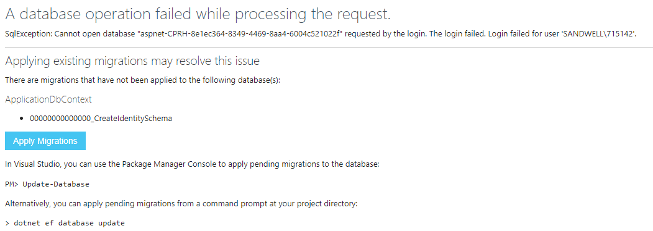

To resolve this error, we must add and update a migration, as it creates the SQL database, and any new models while also updating any changes made. We first run in the Package Manager Console:

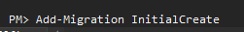

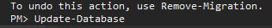

Due to it being our first migration on the solution, we name it ‘InitialMigration’ due to it being industry standard naming convention, afterwards we will name our migrations based off the basic migration neasons which are simple to keep track of.

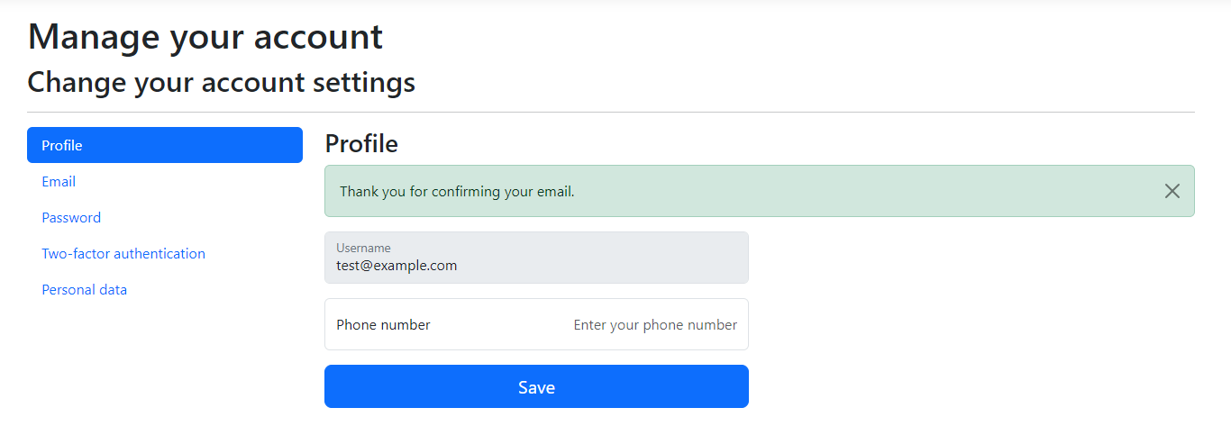

Now that a migration is added, we can create users accounts without the error occurring. This is why we made use of individual accounts, because its given us a user database with a customizable account creation system. Not only this, but it provides amazing security as it has been tested and coded by professionals in the industry.

# Version 0.0.1 – Creating all models required

During Task 1, with the designs, I decided to change some of my data types of the models around. They’re minor changes but still needed to be paid attention to. I changed data types and added new attributes. These are my models before and after.

Table: Rooms [BEFORE]

|  |  |  |  |  |  |
| --- | --- | --- | --- | --- | --- |
| **Data Property** | **Data Type** | **Purpose** | **PK/FK** | **Size** | **Required?** |
| RoomId | INT | Unique identifier for each room | PK | 4 bytes | Yes |
| Name | STRING | Name of the room (or label) | N/A | N/A | Yes |
| Description | STRING | Description of the room | N/A | N/A | No |
| Capacity | INT | Maximum number of occupants | N/A | 4 bytes | Yes |
| Equipment | STRING | Equipment which is available in the room | N/A | N/A | No |
| PricePerHour | DECIMAL | Cost to book room per hour | N/A | N/A | Yes |

Table: Rooms [AFTER]

|  |  |  |  |  |  |
| --- | --- | --- | --- | --- | --- |
| **Data Property** | **Data Type** | **Purpose** | **PK/FK** | **Size** | **Required?** |
| RoomId | INT | Unique identifier for each room | PK | 4 bytes | Yes |
| Name | STRING | Name of the room (or label) | N/A | N/A | Yes |
| Description | STRING | Description of the room | N/A | N/A | No |
| Capacity | INT | Maximum number of occupants | N/A | 4 bytes | Yes |
| Equipment | STRING | Equipment which is available in the room | N/A | N/A | No |
| PricePerHour | float | Cost to book room per hour | N/A | N/A | Yes |
| StarRating | int | Show how many stars the room has | N/A | N/A | Yes |
| GuestRating | double | Guest opinion on how they rate the room | N/A | N/A | Yes |
| NumberOfRooms | Int | How many rooms is in the facility | N/A | N/A | Yes |
| IsAvailable | bool | Is the room availabke for booking | N/A | N/A | Yes |

Table: Bookings [BEFORE]

|  |  |  |  |  |  |
| --- | --- | --- | --- | --- | --- |
| **Data Property** | **Data Type** | **Purpose** | **PK/FK** | **Size** | **Required?** |
| BookingId | INT | Unique identifier for each booking | PK | 4 bytes | Yes |
| RoomId | INT | References the room which is being booked | FK | 4 bytes | Yes |
| UserId | STRING | References user which made the booking | FK | N/A | Yes |
| BookingDate | DATETIME | Date of the booking | N/A | N/A | Yes |
| TimeSlot | STRING | Time range for booking | N/A | N/A | Yes |
| Status | STRING | Current booking status (for example:pending, confirmed, denied) | N/A | N/A | Yes |

Table: Bookings [AFTER]

|  |  |  |  |  |  |
| --- | --- | --- | --- | --- | --- |
| **Data Property** | **Data Type** | **Purpose** | **PK/FK** | **Size** | **Required?** |
| BookingId | INT | Unique identifier for each booking | PK | 4 bytes | Yes |
| RoomId | INT | References the room which is being booked | FK | 4 bytes | Yes |
| UserId | STRING | References user which made the booking | FK | N/A | Yes |
| BookingDate | DATETIME | Date of the booking | N/A | N/A | Yes |
| StartTime | TimeOnly | Start time for booking | N/A | N/A | Yes |
| EndTime | TimeOnly | End time for booking | N/A | N/A | Yes |
| Status | STRING | Current booking status (for example:pending, confirmed, denied) | N/A | N/A | Yes |

I removed the AccountInformation model as we are using IndividualAccounts, account data can be gathered by AspNet Identity within the solution because of this, making an AccountInformation model redundant. However, I implemented a new model for staff so that staff emails can be logged and displayed.

Table: Staff [NEW]

|  |  |  |  |  |  |
| --- | --- | --- | --- | --- | --- |
| **Data Property** | **Data Type** | **Purpose** | **PK/FK** | **Size** | **Required?** |
| StaffId | INT | Unique identifier for the staff information record | PK | 4 bytes | Yes |
| FirstName | STRING | First name of staff | N/A | N/A | Yes |
| StaffEmail | STRING | Email of staff |  |  |  |
| StaffPhoneNumber | STRING | Phone number of staff | N/A | N/A | Yes |
| Role | STRING | Staff role in CityPoint Room Hire | N/A | N/A | Yes |

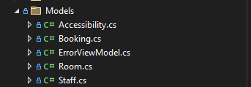

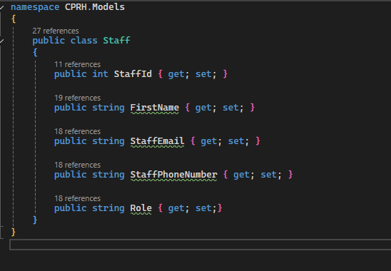

We now make the Model files with appropriate names and the data which they’ll store. This is an example from the Staff model. From this, I scaffold each model one by one, preventing the solution explorer from being untidy and making the organization and navigation of the solution easier. Although, we need to scaffold the identity pages to allow us to edit the register, sign up pages and more.

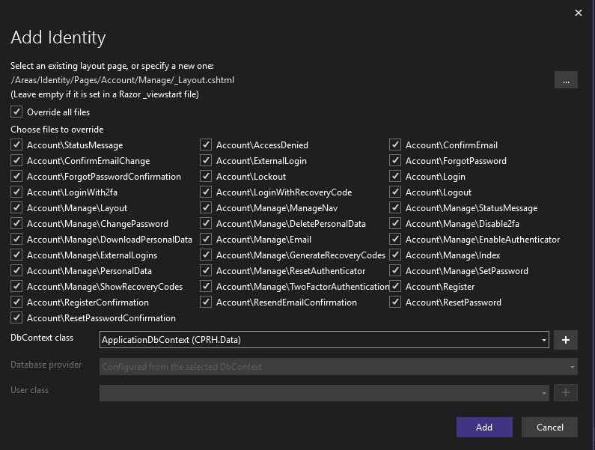

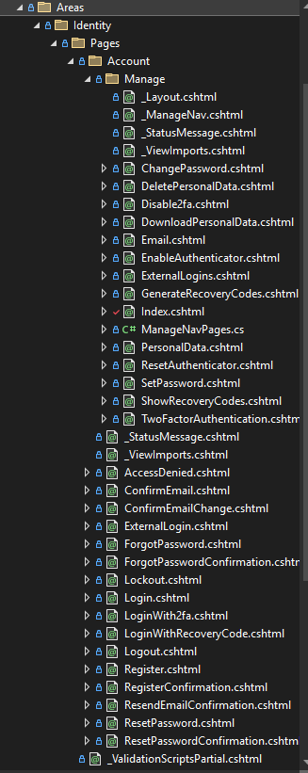

This now lets us edit all pages shown whenever we need. Not only this, but I chose to scaffold it now rather than later so its all organized into one folder which is rarely opened. However, when working on such as the HTML of the solution, we are required to open the whole folder with all other pages which would have been created when scaffolding, which is messy and a hassle to navigate through, with the biggest reason for not scaffolding so soon being able to focus on the features one by one, making sure its complete fully without providing broken or incomplete features before continuing.

# – Adding Google Authentication

Firstly, it is often seen in the industry that solutions offer Google Authentication as it allows for a larger audience to access the website, adding page traffic. Not only this, but it makes your website more accessible as more people prefer to and feel more secure when logging in with Google.

We’re going to start by heading over to the Google Developer Console. I am going to create a project related to no organization using my email. I am then going to head over to the API and services section where I will create an OAUTH Client ID. I will make the URL redirect to the correct project and choose ‘signin-google’. I will make it the local port the solution runs off for now as the website is not yet hosted online.

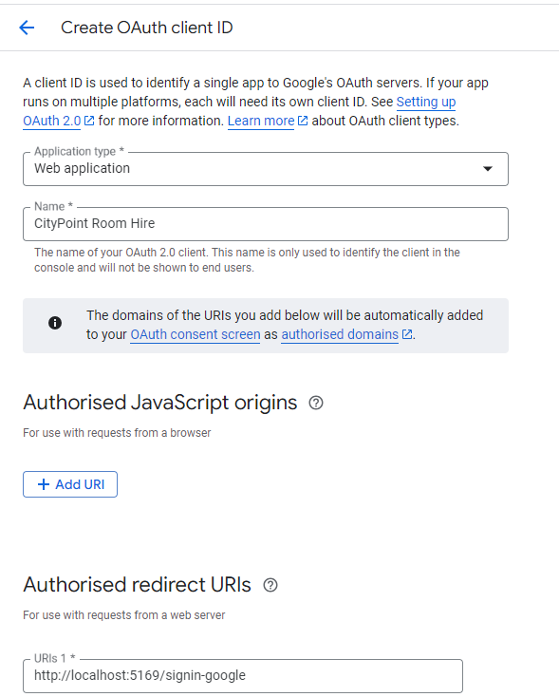

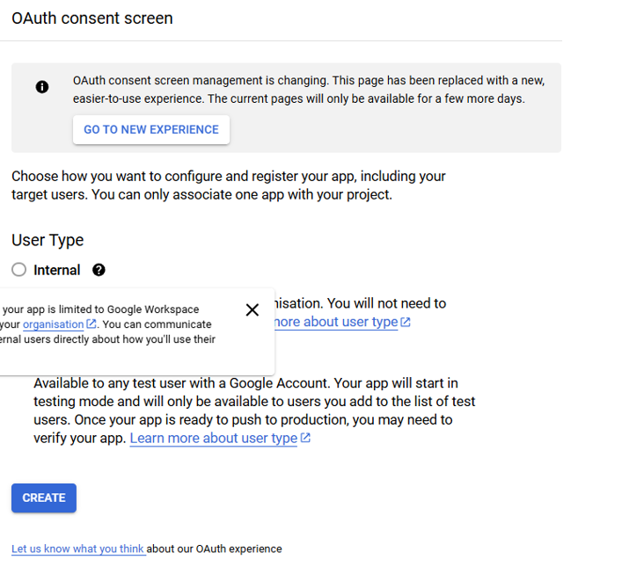

I also had to configure the consent screen so that users are consented with the appropriate permissions. I also had to choose the brand name, which I inputted ‘CityPoint Room Hire’.

I was then provided with a ClientID and Client Secret which I will use in my solution to link to the google authentication API to provide a working login system.

We previously installed the Google Authentication package.



This will make it so that I can use the google ClientID and Client Secret in the appsettings.json and program.cs file. In the appsettings.json file, I implemented the Google section:

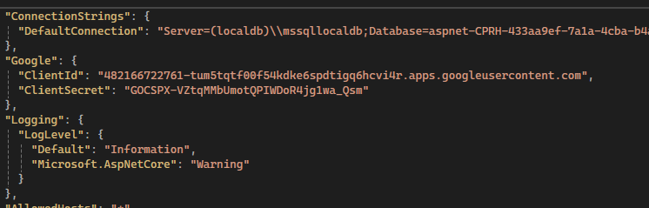

And in program.cs I added the following code:  
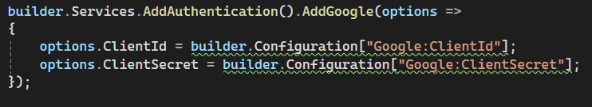

Because of this, I am now able to login using google when running the application.

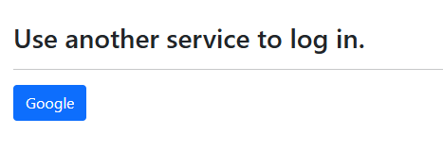

# Version 0.2.1 – Creating the Room Booking System and allows rooms to be purchased

I made sure userId was being ran through controllers to ensure that all bookings are related to the user creating the bookings. I also made sure that admins have access to all bookings and user access is somewhat limited. I also added implication for filters and ensuring that the roomId is always set as the correct roomId and that the status of the room is always ‘Pending’ by default when the booking is first created, and it cannot be changed by the user without admin privelleges. I made sure to use ModelState remove where appropriate to remove UserId and Room model from the view and so that it cant be changed for the booking set, and I also made it so that the user will be provided an error message if the room is not available. Not only this, but I also implemented the logic that users may want to delete their booking to make a new one or if they simply don’t want to book anymore rather than making it so they cant delete any bookings. However, they can only delete bookings which are linked to their own userId, not other user bookings. Admins can still delete any booking, however.

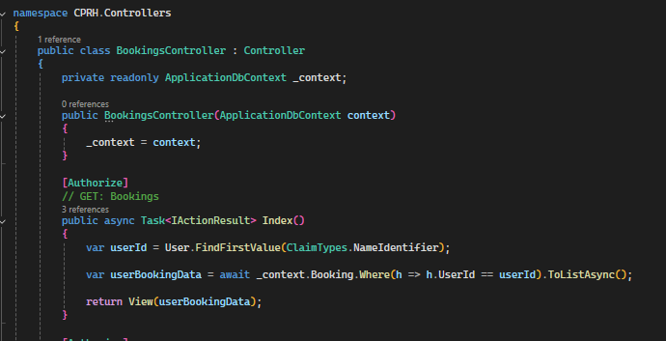

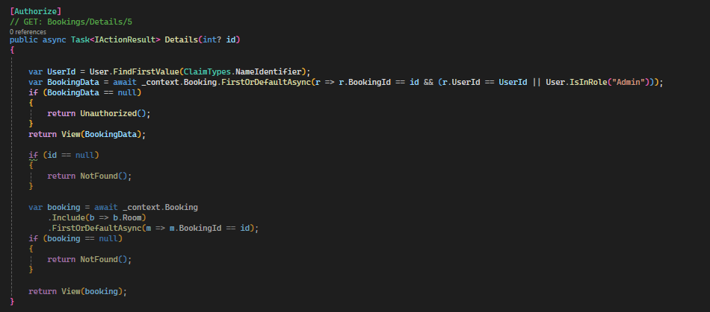

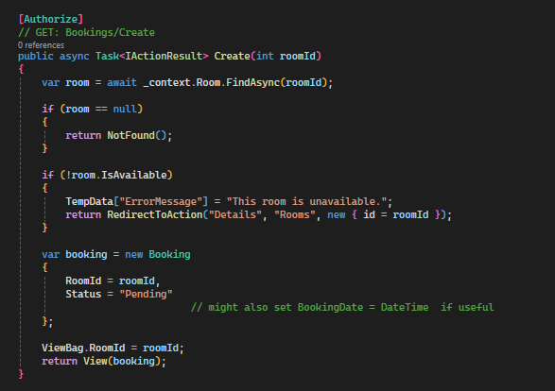

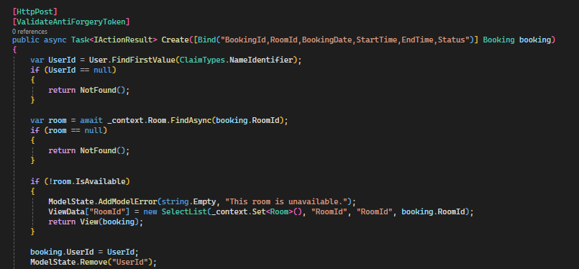

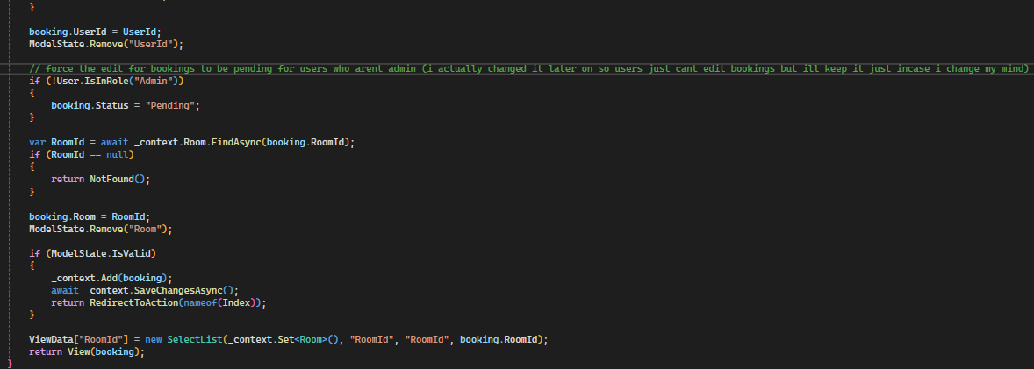

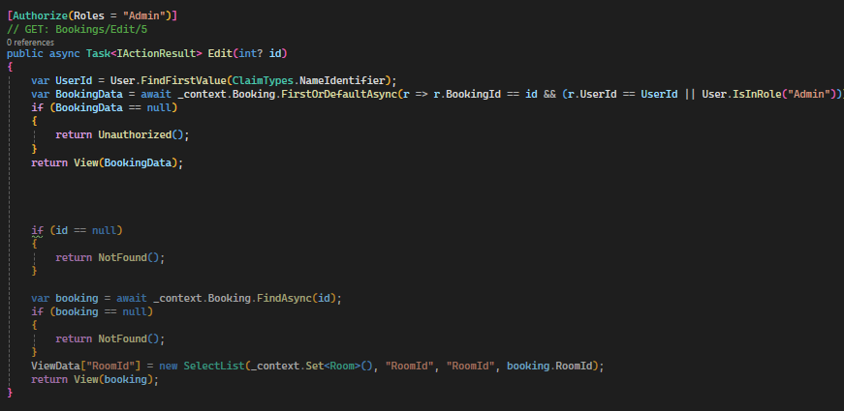

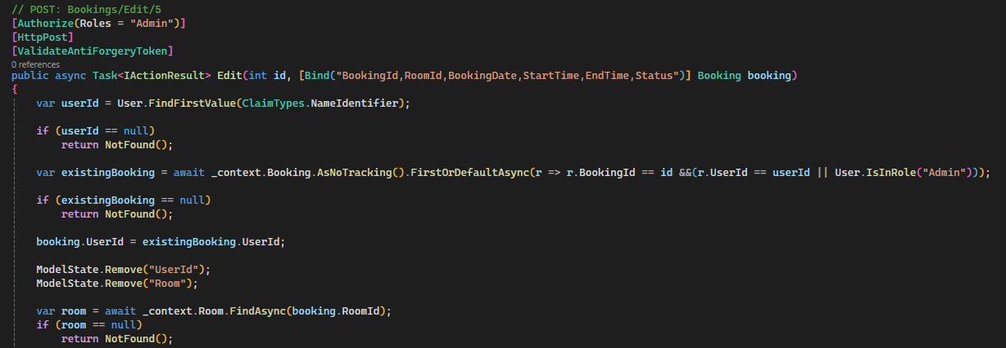

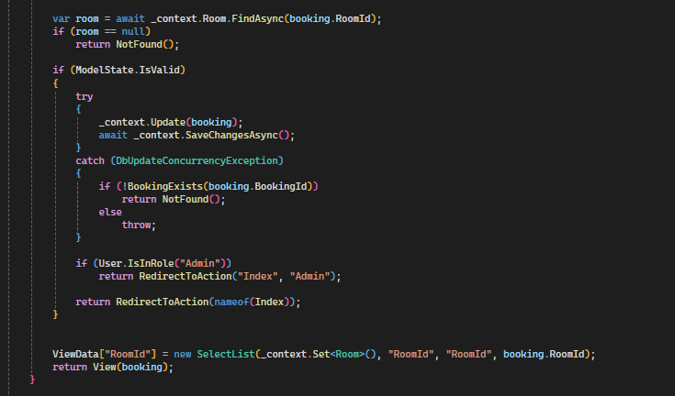

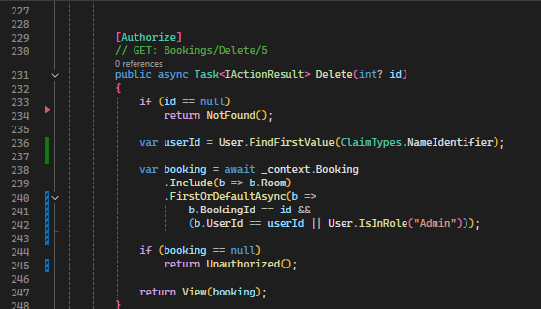

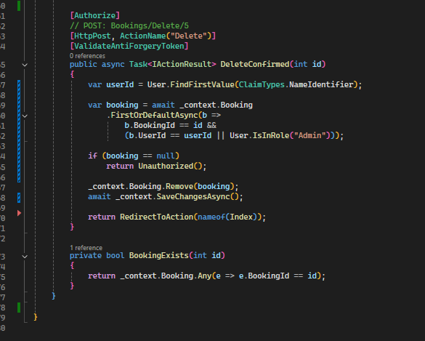

# Version 0.2.2 – Seeding data for development, so the website is usable on startup from any location, helps with development and makes it so data doesn’t need manual loading

Firstly, we make a new file called SeedData within the data folder. I then added all the code into the file, seeding data for Rooms and Staff accounts. I also seeded data for booking, which used a separate method as bookings are linked to a userId, I used example emails just for demonstration purposes.

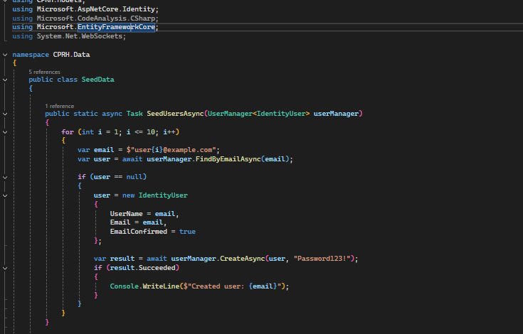

(repeats New Booking 10 times)

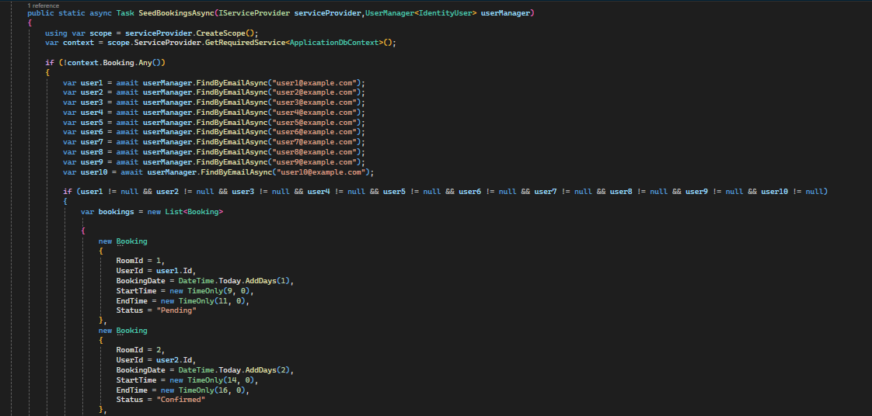

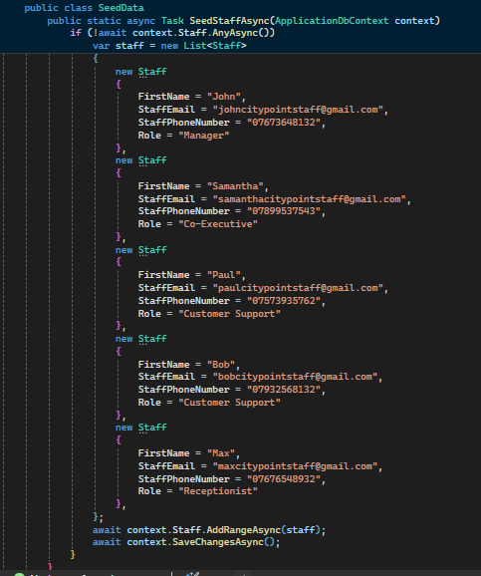

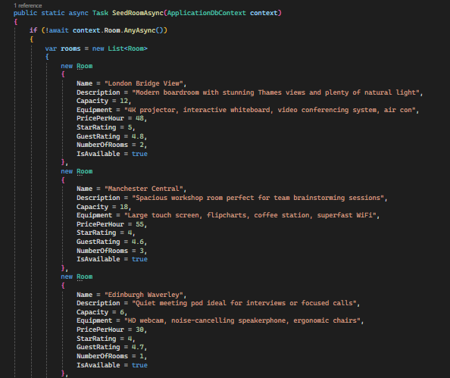

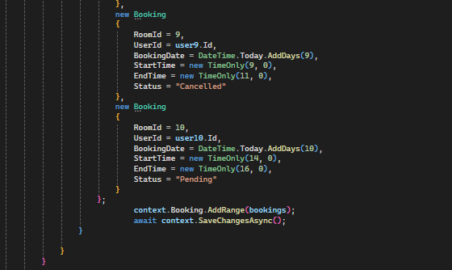

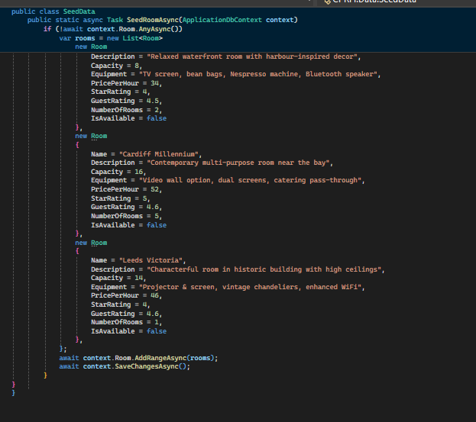

Then we initialize it within program.cs:

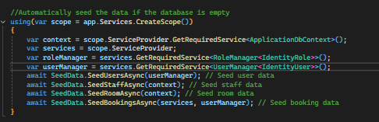

We can now see that after updating the data-base and running the program, the data has been added to the SQL server successfully.

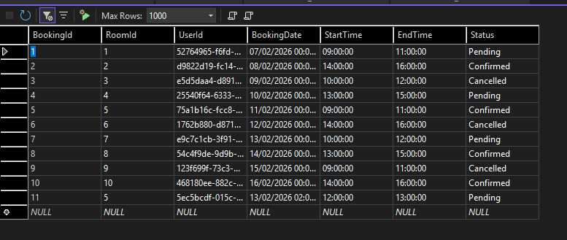

# Version 0.2.3 – User Roles

Whilst still working on the SeedData file, I thought it would be appropriate to add user roles so that users can login with administrative permissions. I did this by implementing the following code into the SeedData file:

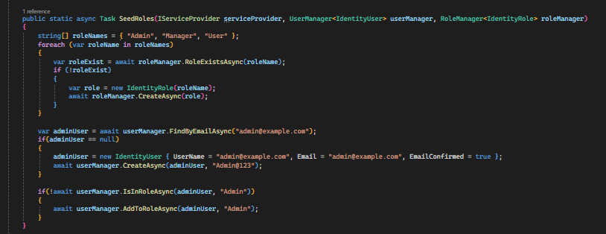

I then implemeneted the following line into the program.cs file:



After this, I ran Update-Database in the console and attempted to login using the admin email and password:

[admin@example.com](mailto:admin@example.com)

Admin@123

Doing so now works just fine.

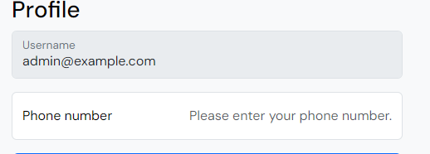

# Version 0.3.3 – Stylizing nav bar, footer and landing page.

Firstly, we need to create CSS to make the navbar and footer have corrected and consistent styling throughout the page. I am using custom made CSS alongside bootstrap to make a clean industry standard navbar and footer which have great compatibility throughout my website. I also made use of @@media for responsiveness, (usually it is @media but it bugs out with Razor views)

Nav bar:



Footer:



We are trying to follow the same consistency throughout the whole website with the wireframes we have made to create accuracy for the client

When screen width is adjusted to a smaller display, such as mobile or a small screen, the navbar and footer will adjust to ensure accessibility from all devices.

Mobile/Small Display:

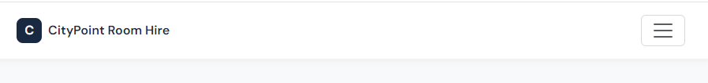

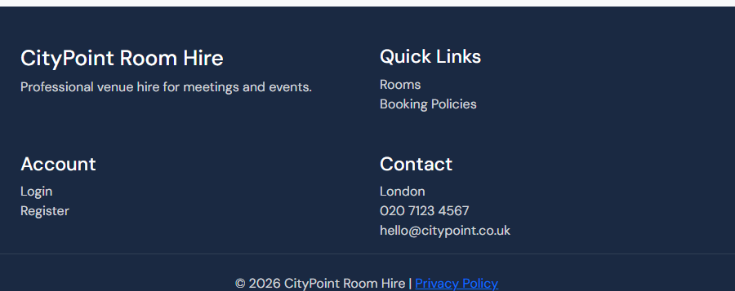

Now I started adding content to the main page. I went with the same design as the wireframe, showing off the companies reliable and professional feel and showcasing rooms and policies. You must scroll down the page, it is not all showcase in one. (scroll visible on left hand side)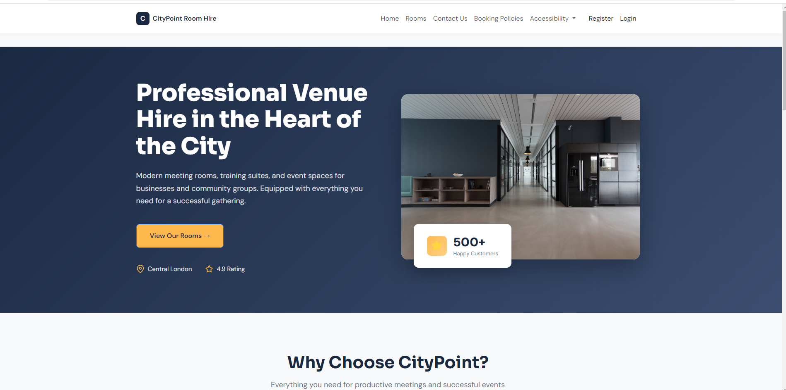

That is how it looks on desktop, as you can see, it is also adjusted for mobile and smaller screen views.

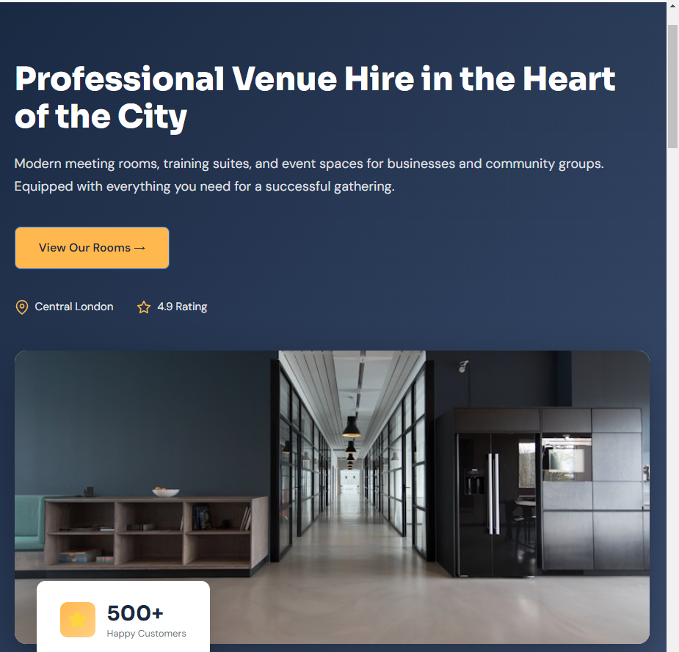

I will keep the same mobile and desktop friendly logic throughout the whole page, from now on I will only display desktop layouts.

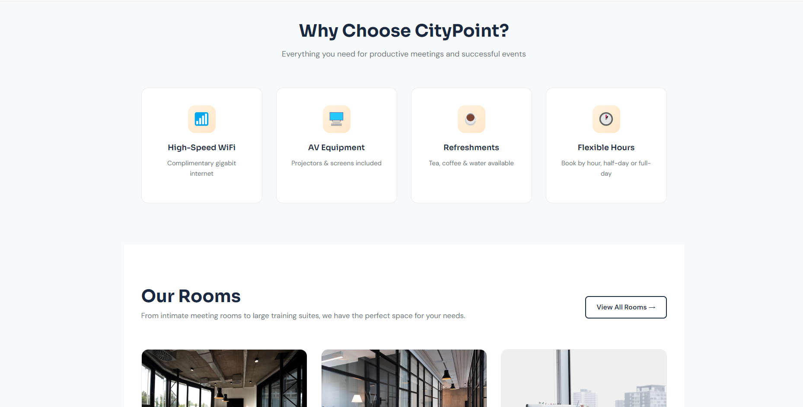

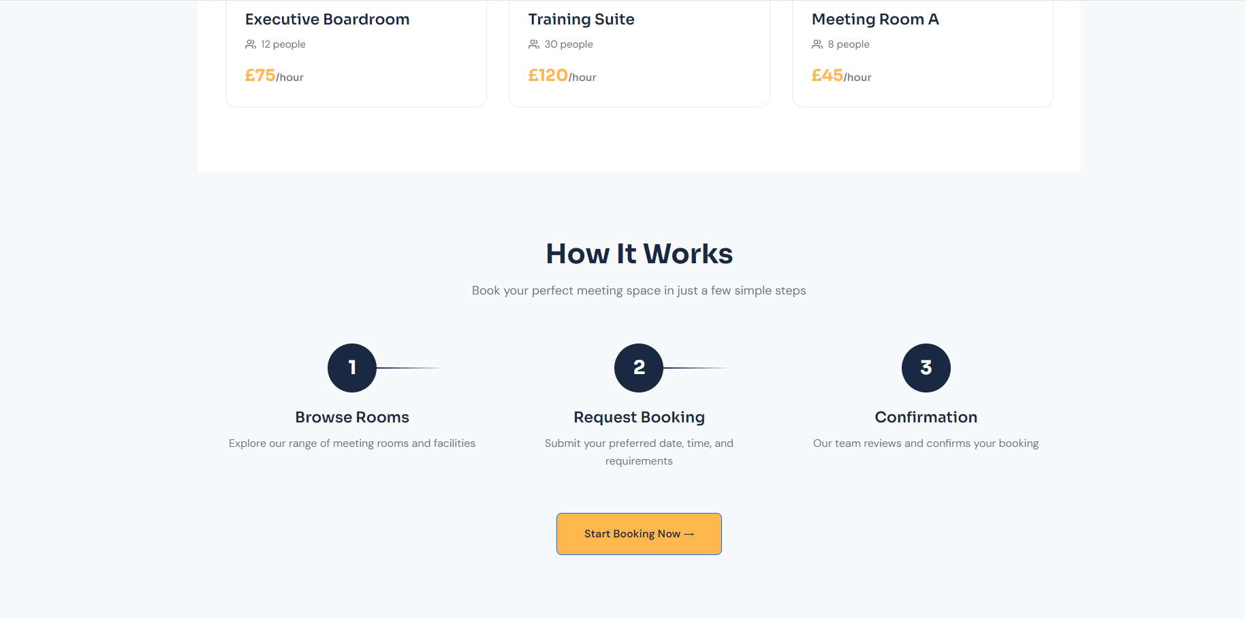

Here is some preview code of the view:

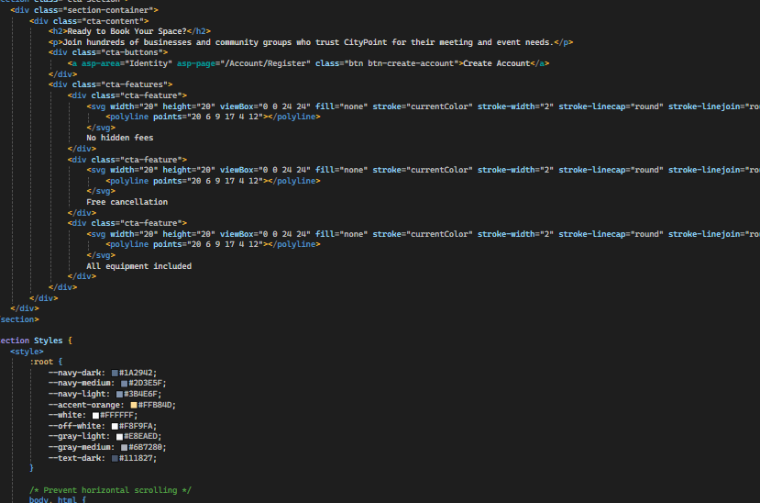

# Version 0.4.3 – Stylizing the rooms (room booking) and booking policy page

Some code from the Room Booking page:

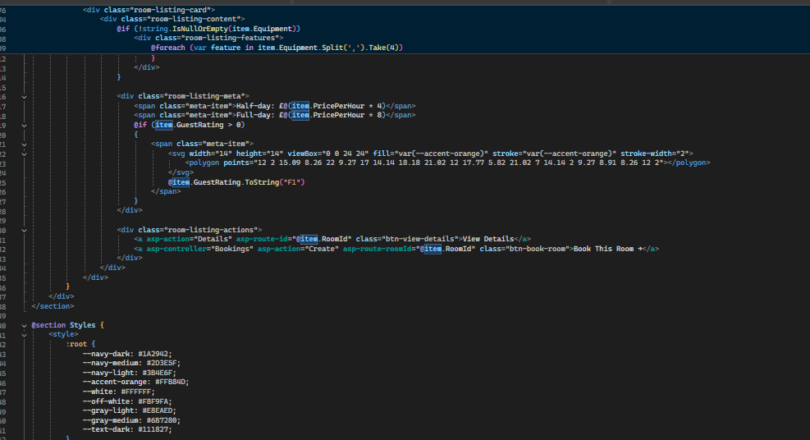

I ensured that code logic and flow is consistent throughout the page. I also called a lot of logic from the controllers and models through functions I previously made in the controllers. I used these to implement filters and data which is actually taken from models to be relevant to the seeded data rather than showing display only data. This was done with @model logic and more.

This is how the room page looks, you can scroll down to see a list of cards with all available rooms with relevant data actually linked to each room:

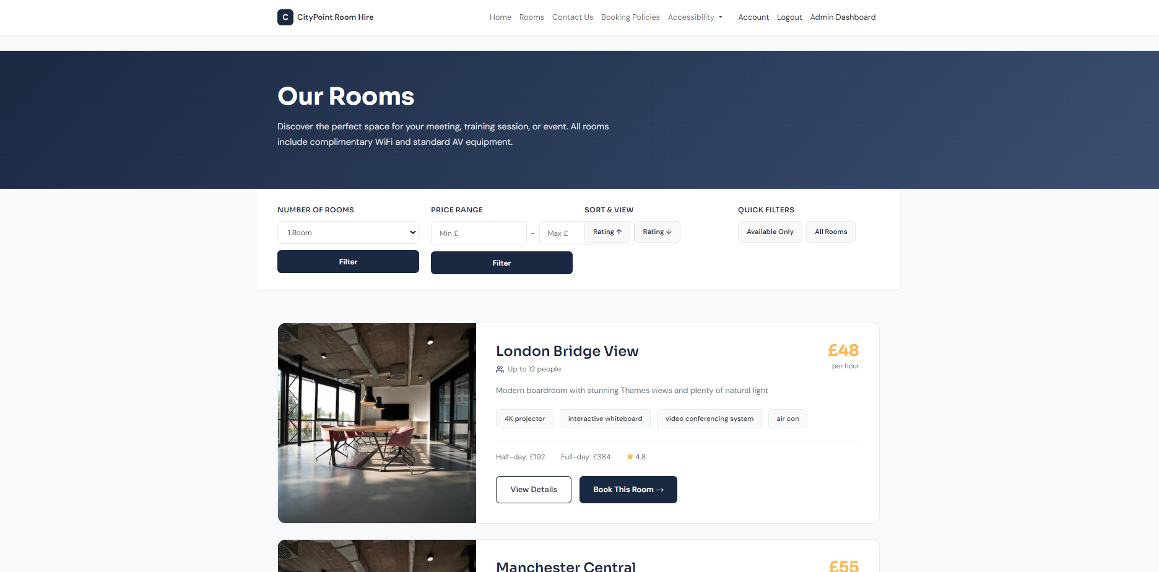

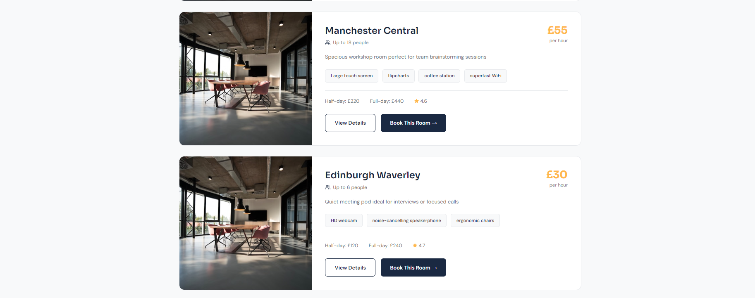

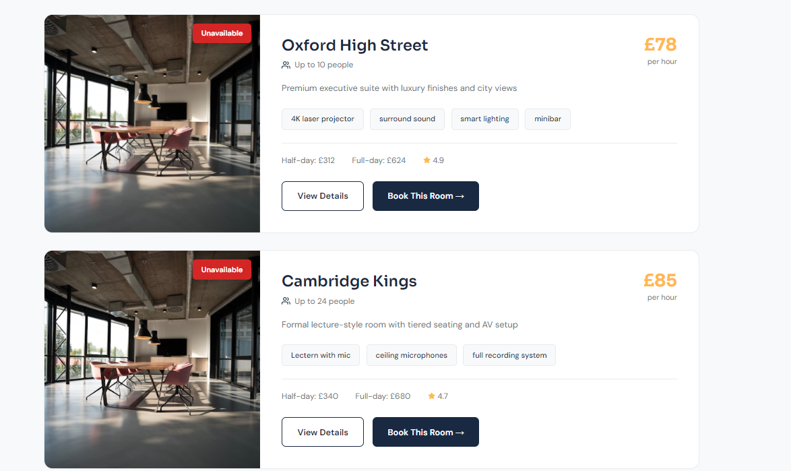

All buttons have correct logic and take you to the respective booking.

For the Booking Policy page, it is front end only, just to represent the brands qualities. Here is how it looks:

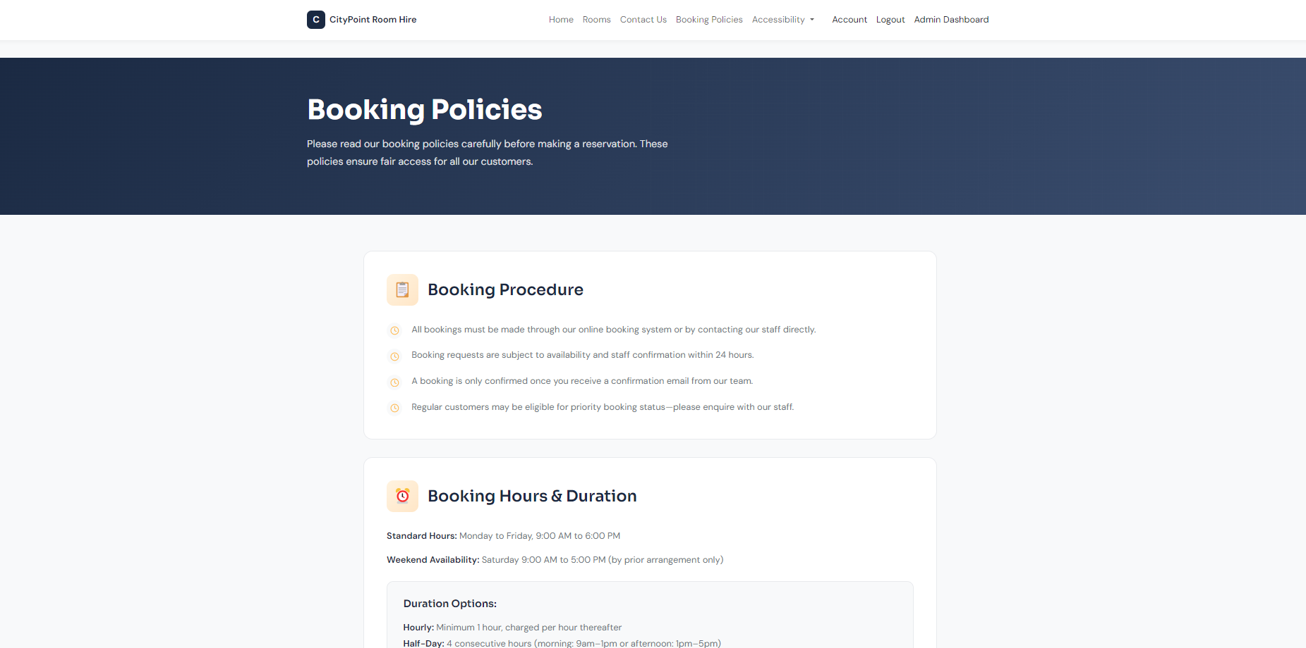

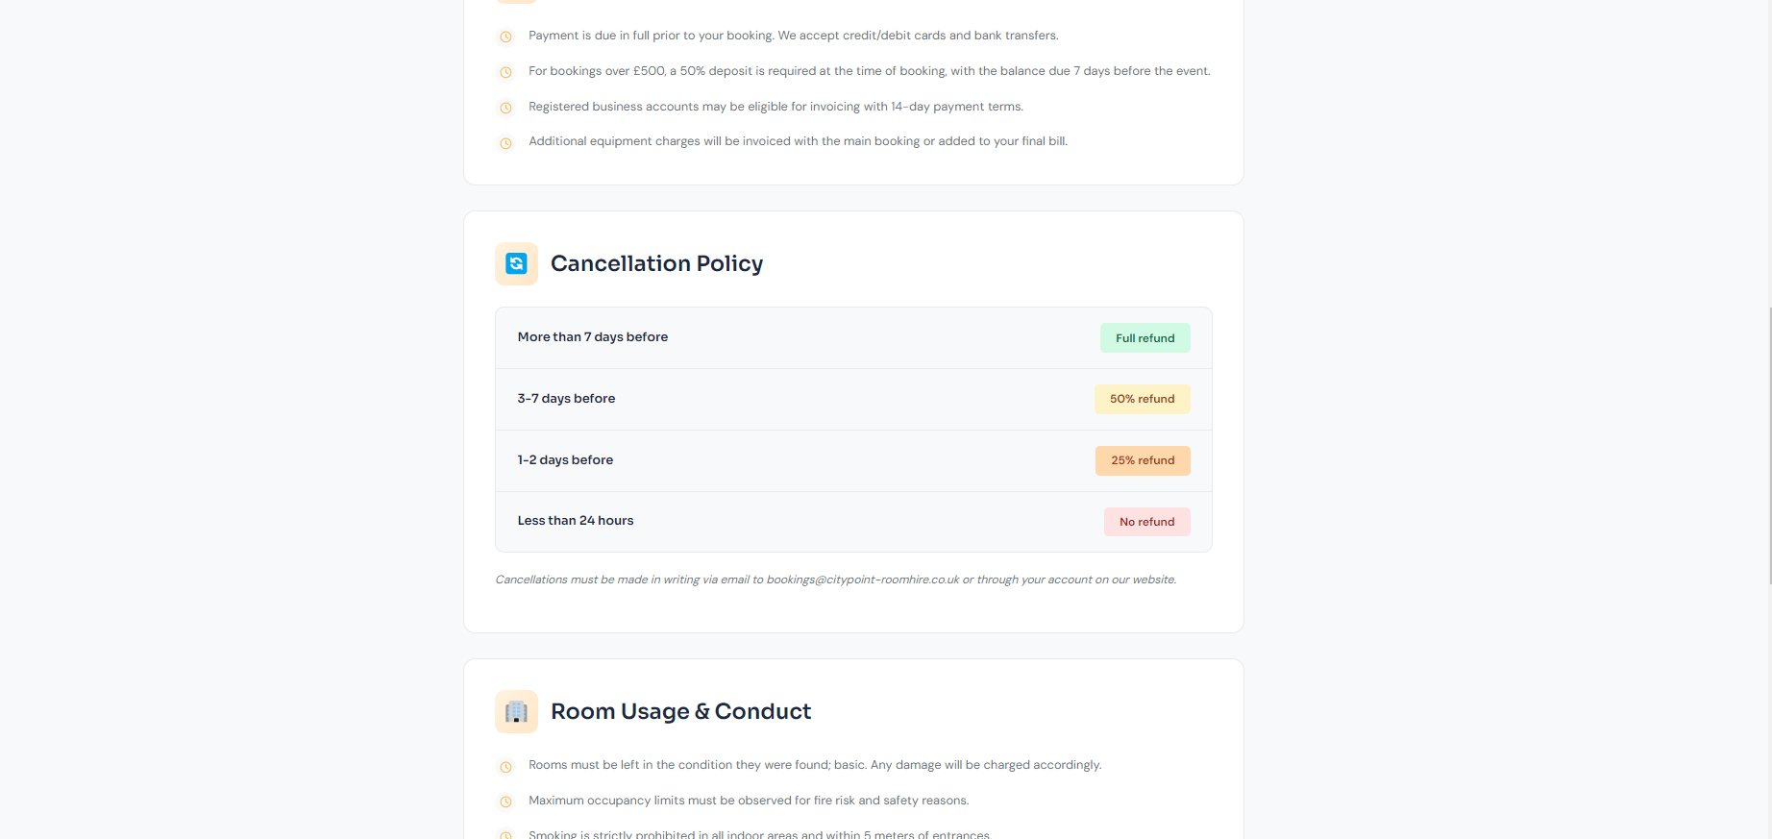

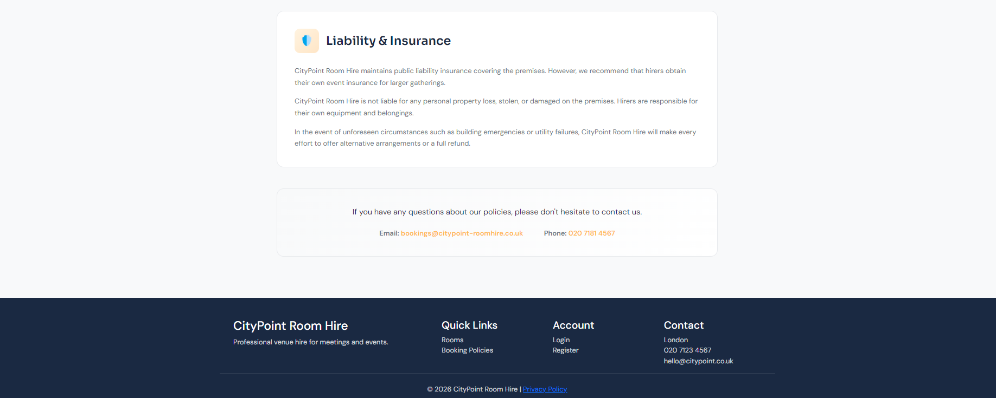

I used emojis and will use emojis throughout the site as they’re very accessible. They’re able to be displayed on a large variety on devices, and are easily implemented for accessibility features like text to speech as they’re actually read out.

# Version 0.5.3 - Sylizing the Contact Us and Accessibility Page

I used the same logic in previous versions of the project. I added company details with a template ‘Send us a message’ which can easily be linked to a company email, for now, the button just sends an empty post request and refreshes the page. 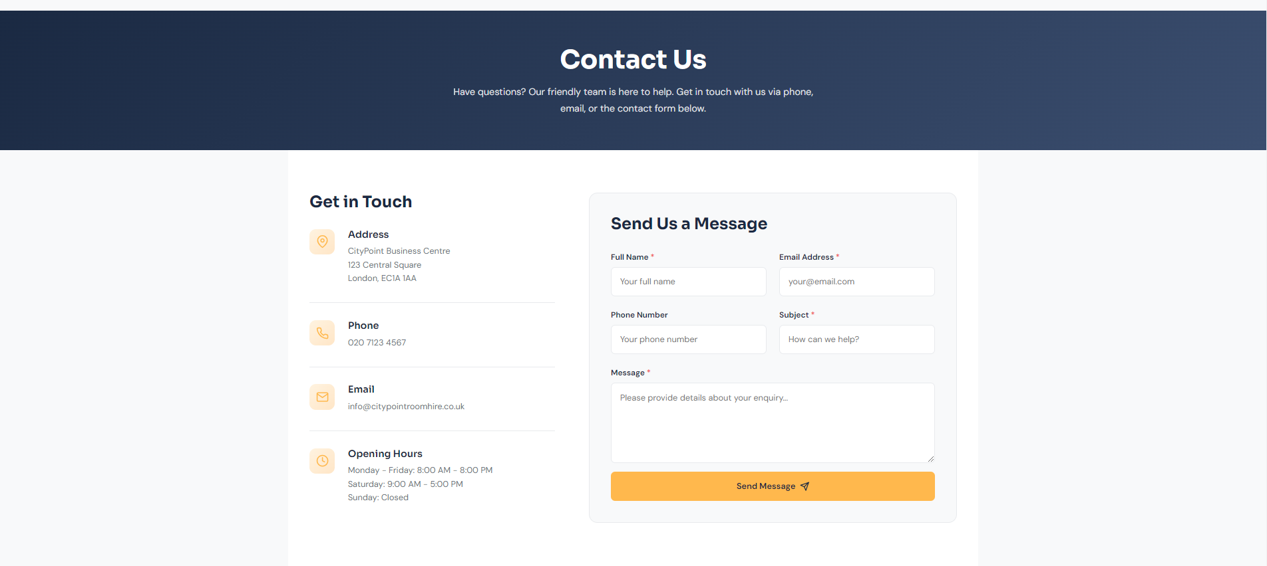

Once you scroll down the page, you are presented with staff which are actually linked from the Staff Models (for now using staff from seeddata like in the rooms model). Not only this, but an appropriate map which could show the business location of CityPoint Room Hire could also easily be implemented here.

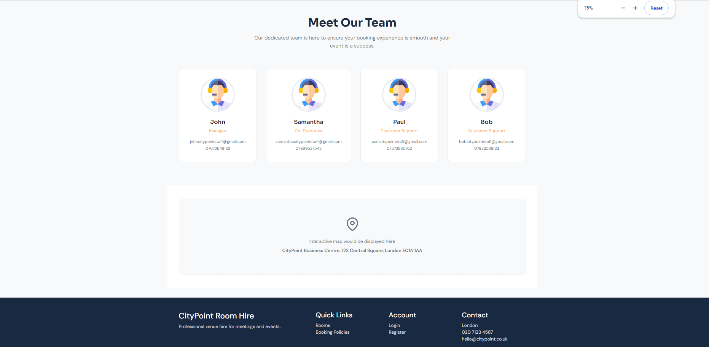

Here is some code from that page of HTML and CSS:

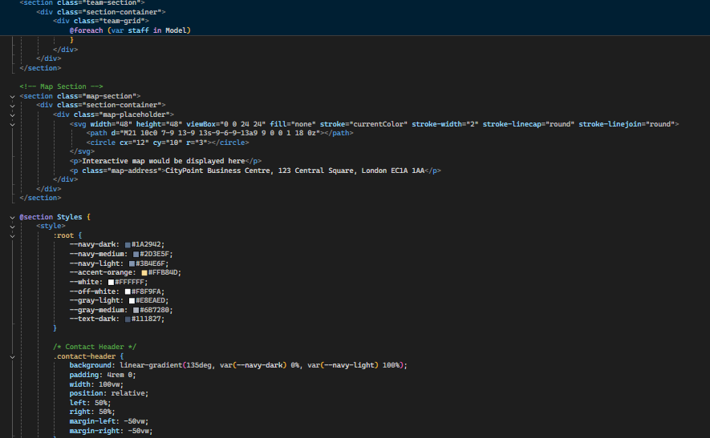

Then there is my Accessibility page, which like my Booking Policies page, only contains front end. No back end logic is required. Like other pages, it is following consistency of the website and trying to go based off of the wireframes.

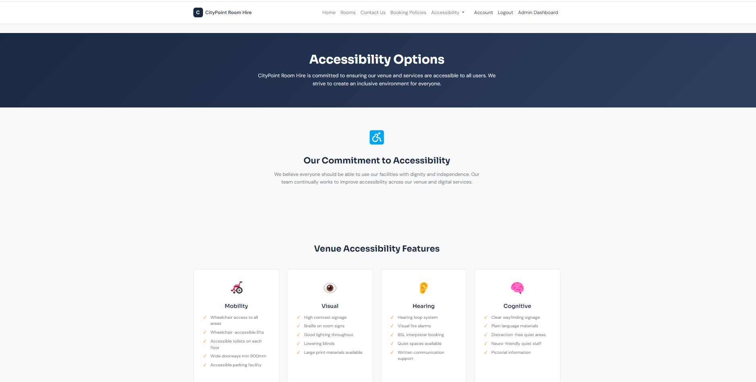

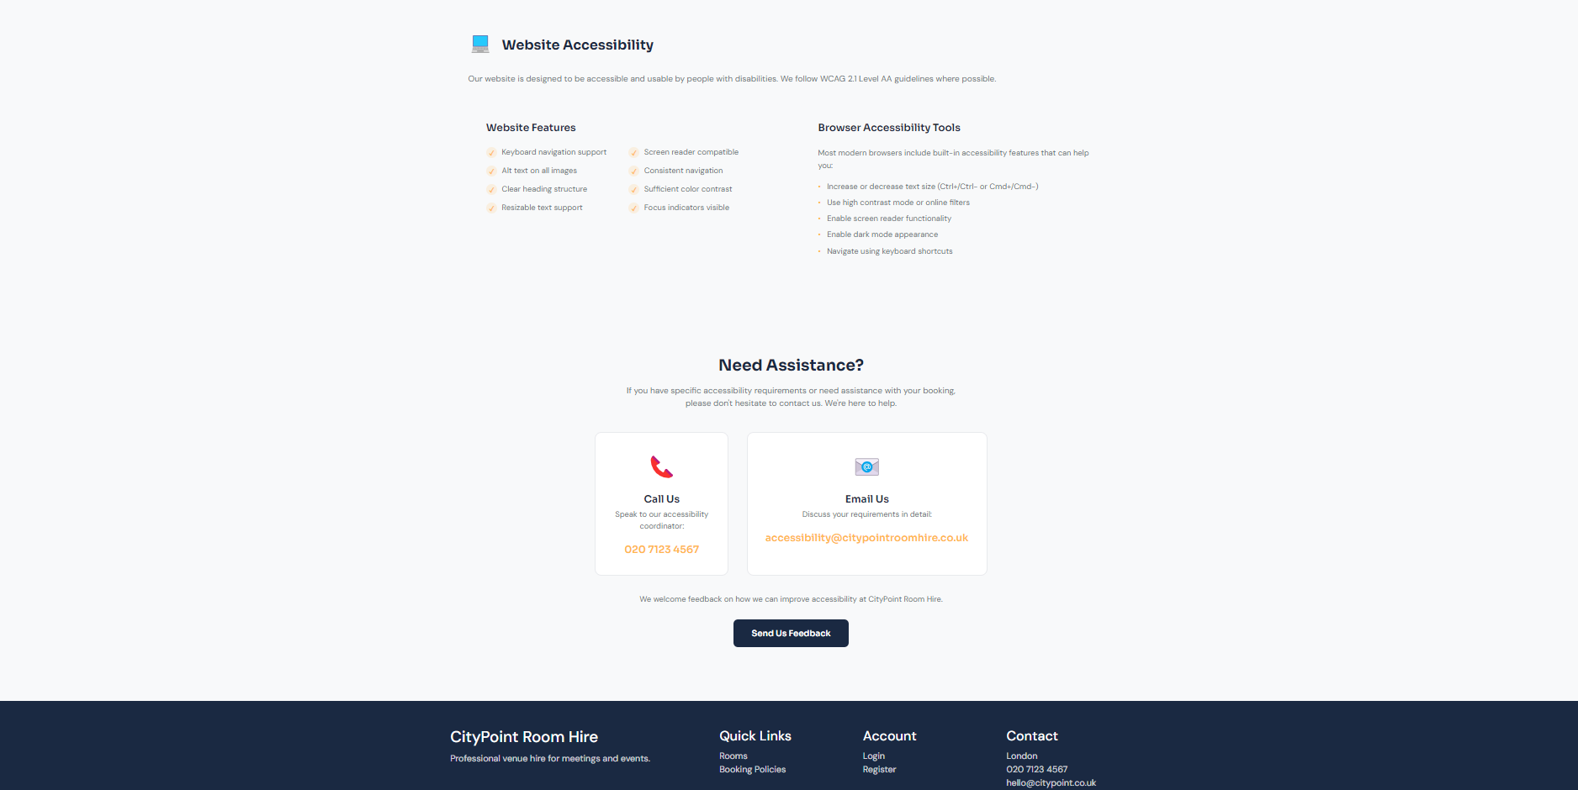

Here is some code from that page:

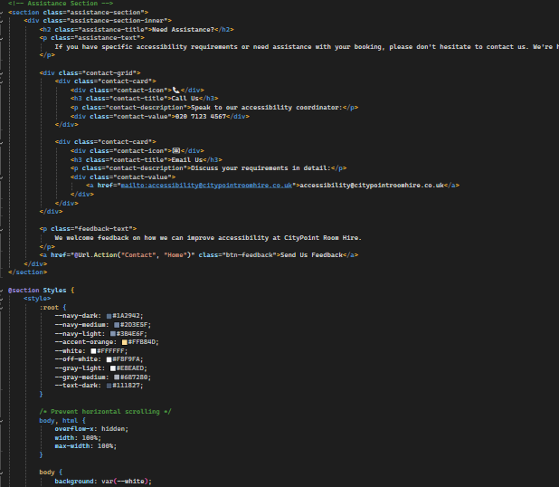

# Version 0.6.3 – Ensuring Security throughout the website

Where necessary, admins should be able to see certains buttons and users should not be able to see certain pages. I can do this through [Authorize] and [Authorize(Roles = "Admin")] above post and get methods which shouldn’t be accessed by users. Not only this, but [Authorize] should be on everything booking related to ensure only logged in users can make access of booking systems. Here is an example

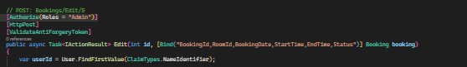

Now, when a user tries to edit a booking, they’re provided an error message.

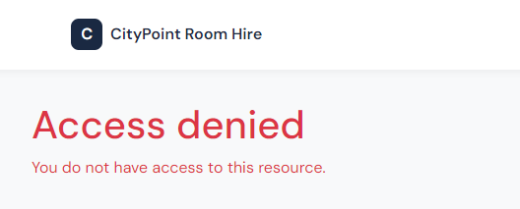

# Version 0.6.4 – Adding the admin dashboard to the navbar of the website

Through changing code in the same place where Account and Login is held in the navbar, an admin dashboard button can be previewed. I did this with this logic:

@if (User.IsInRole("Admin")) // because only admins should see an edit button

{

<**a** **asp-action**="Edit" **asp-route-id**="@item.BookingId">EXAMPLE</**a**>

}

This is how it looks:

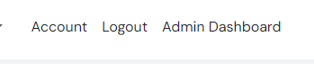

It successfully navigates admins only to the admin dashboard page which I will styleize.

# Version 0.7.4 – Admin Controller

Here, we added a bunch of logic using other models with the help of viewbags and .Include with the use of variables. This was done to allow for search filters and accessible data on the staff dashboard so that relevant data can all be linked and displayed to staff, whilst being accessible. This is mainly viewmodels, filters, links and viewbags.

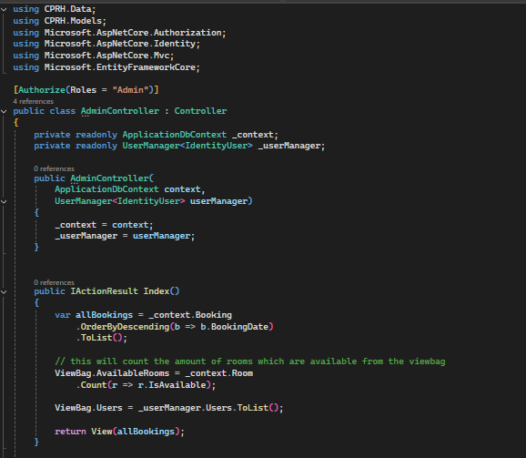

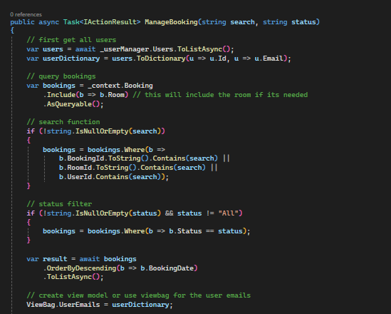

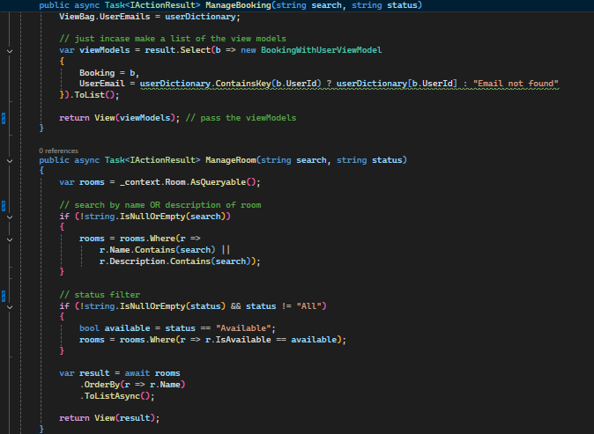

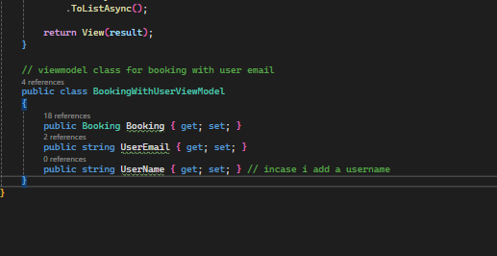

# Version 1.7.4 – Staff Dashboard

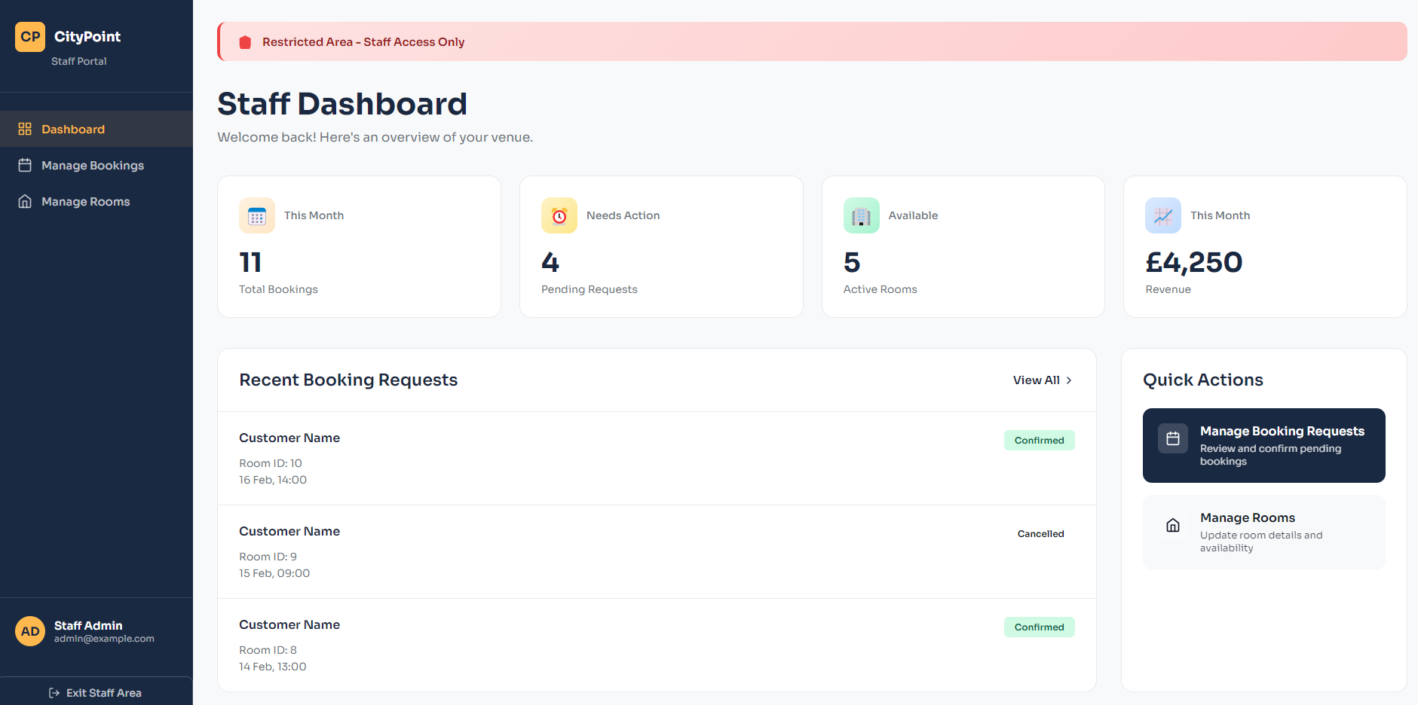

This is the index of the staff dashboard which is accessed through the navbar. Using security checks [Authorization] only admin roles can access this page. This page shows primarily data which are all linked to relevant models. For example, the confirmed status on each booking is true data taken from the SQL server. Same with the logged in user at the bottom left, using ASpNet Identity the admin account logged in is previewed. At the top it shows live data, which will change depending how many bookings there are. There is a dashboard on the left to manage bookings and rooms. At the bottom, there is also a semi-urgent preview showing that there are booking requests which are pending (which is based off live data) and that it must be reviewed. All buttons are linked to the correct pages.

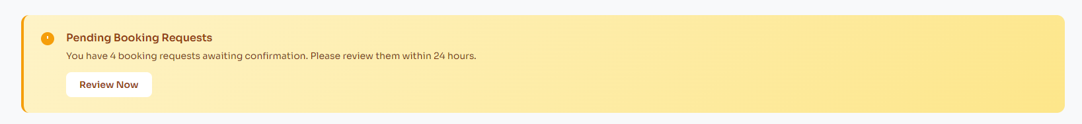

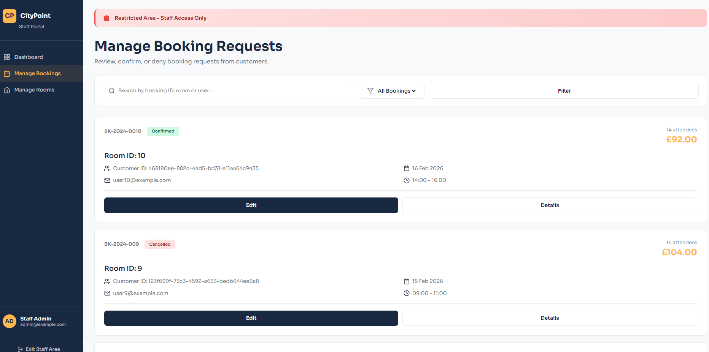

This is the manage bookings page, which displays ALL bookings held in the SQL server, alongside their status. Here you can edit, view details and delete any bookings. All data are linked to the bookings, like the price. This is all live/relevant data taken from the SQL server and implemented into each card, linked with the BookingId to get this info. It also users userId to show who the booking is coming from. The filters also work, you can filter the status of each bookings and you can search bookings through customer Id, booking ID and room ID. The staff user can click edit or details, and it will send them to the booking edit or detail page related to that booking Id, allowing them to make changes, view details or delete bookings.

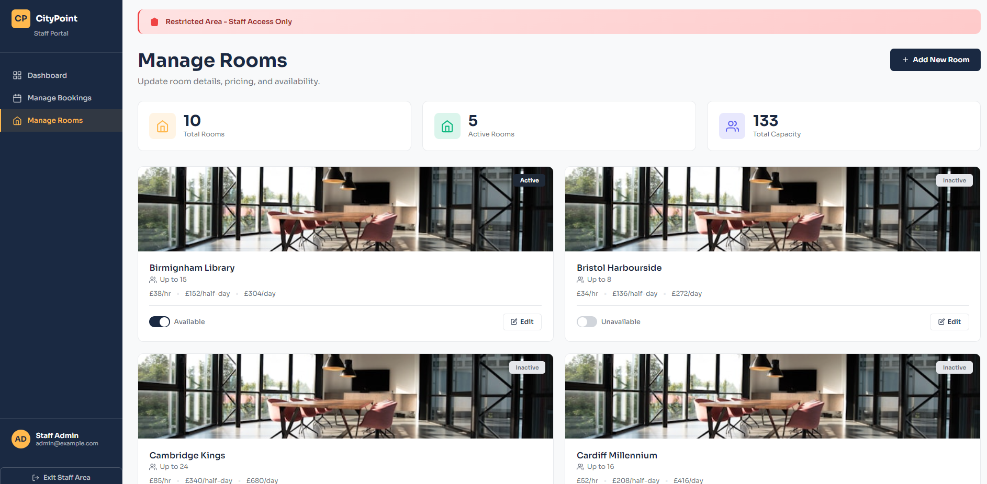

The manage rooms page is also like this, displaying live data of total rooms, active rooms and the total capacity of each room. Then, each card for the rooms preview the availability of the room with the price per hour, day and half day. It also previews capacity of each rooms. The staff has the option at the top right of the page to add a new room, and on each card they can make edits to a room which will take them to the relevant page related to that roomId.

Ill preview code which is consistent for each page, just with different contexts based on each page.

Filters:

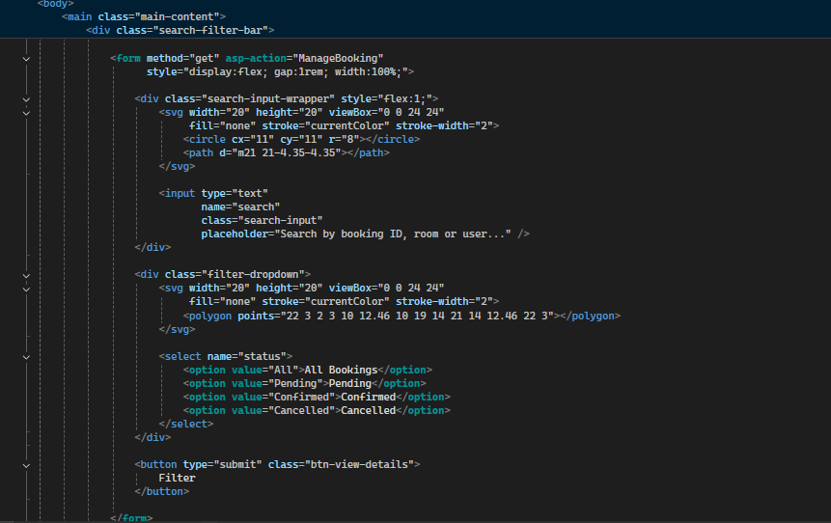

HTML + CSS:

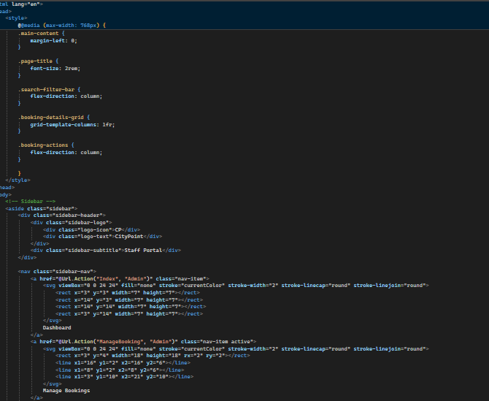

Admin identity being called and url actions:

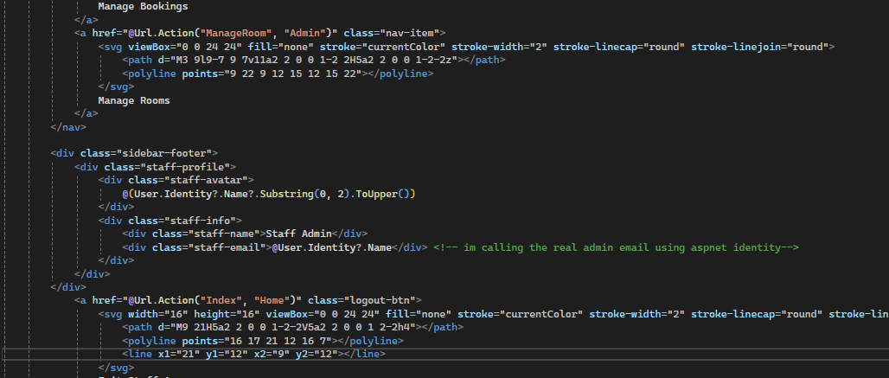

Alert box (index):

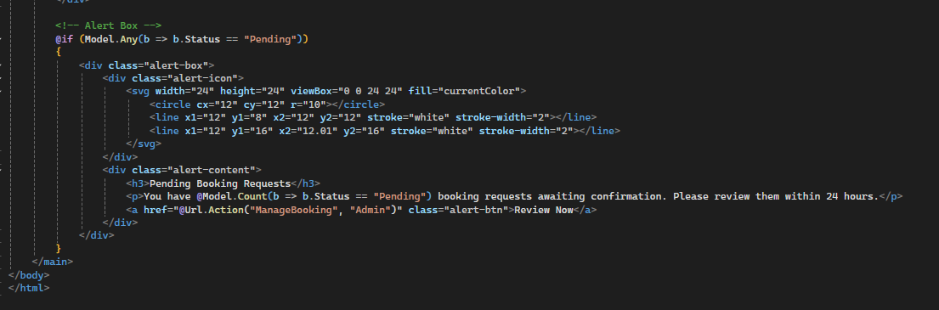

Statistics:

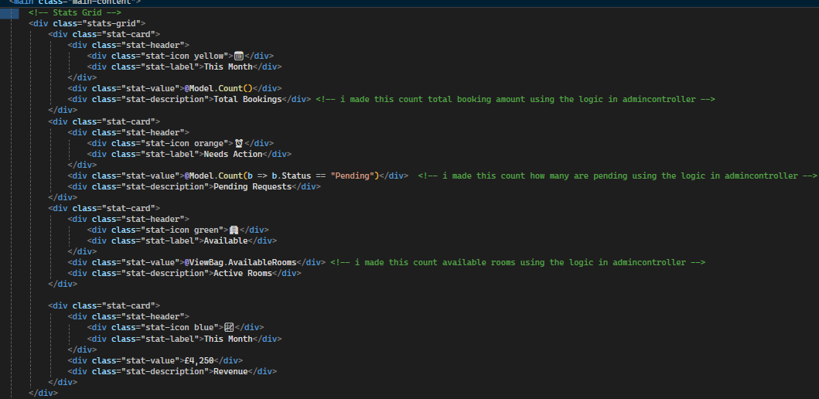

The CSS and HTML styling I went for is because staff dashboard layouts are typically like this in industry standard, with the sidebar on the left and information taking up the main page.

# Version 1.8.4 – Accessibility Settings

It is industry standard to implement accessibility settings into your website. Doing so ensures the website and company implies with WCAG and WC3 regulation. Through the website doing this, it is also open to a larger scope of users. We can create this reliability for the brand by implementing features like high contrast, text reading, adjustable font sizes and a dark mode on the website.

To do this, we first need to create a new Javascript file in wwwroot/js called accessibility.js

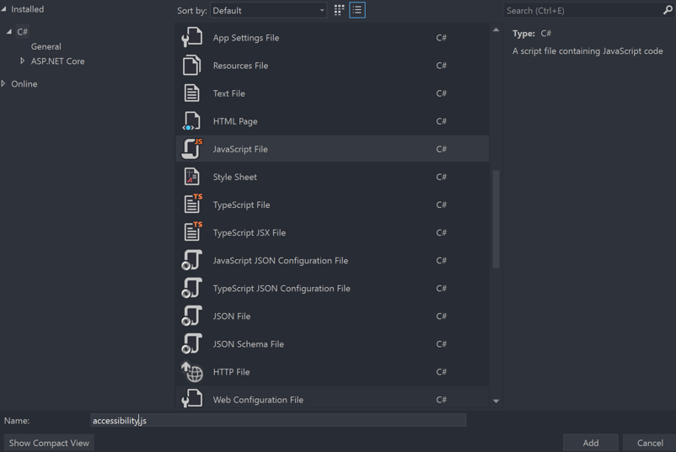

In the accessibility.js file, I wrote this code. We need to ensure that every accessibility function goes inside this event listener so that it can be called upon for each page,

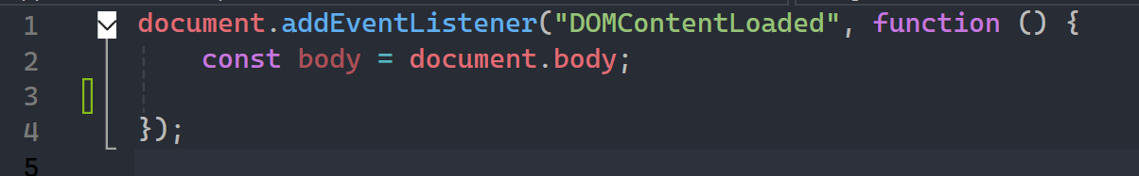

After this, I implemented CSS to inside of wwwroot/css in site.css so that the program knows how I want the css to look.

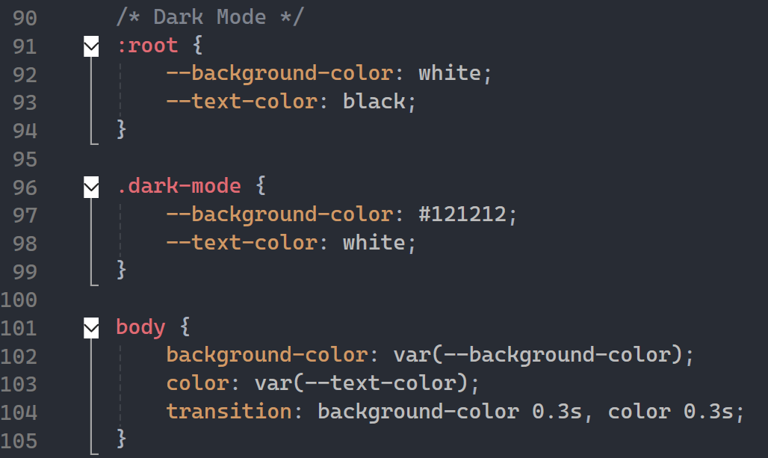

I then added the following javascript to accessibility.js to make a toggle for dark and light mode:

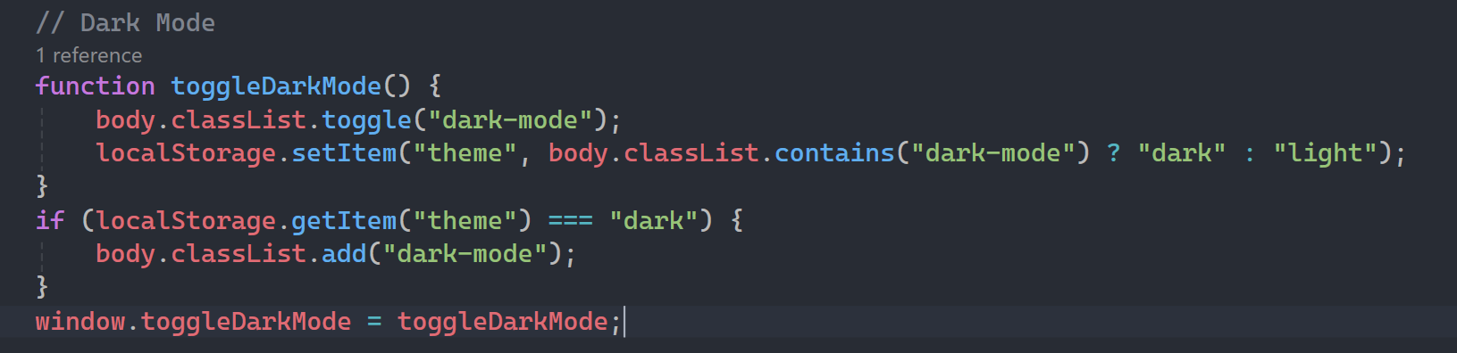

I added this button to Layout.cshtml which allowed the option to be toggled.



I then added a reference link

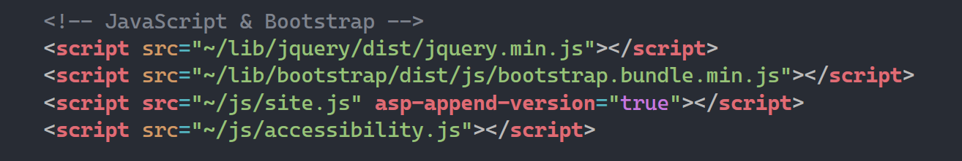

The function was working, but wasn’t applying to all my CSS on my page, so I added some extra CSS to ensure that it would work as intended.

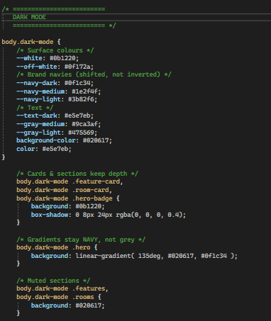

Now, when I click the dark mode button when running my page, it works as I intended.

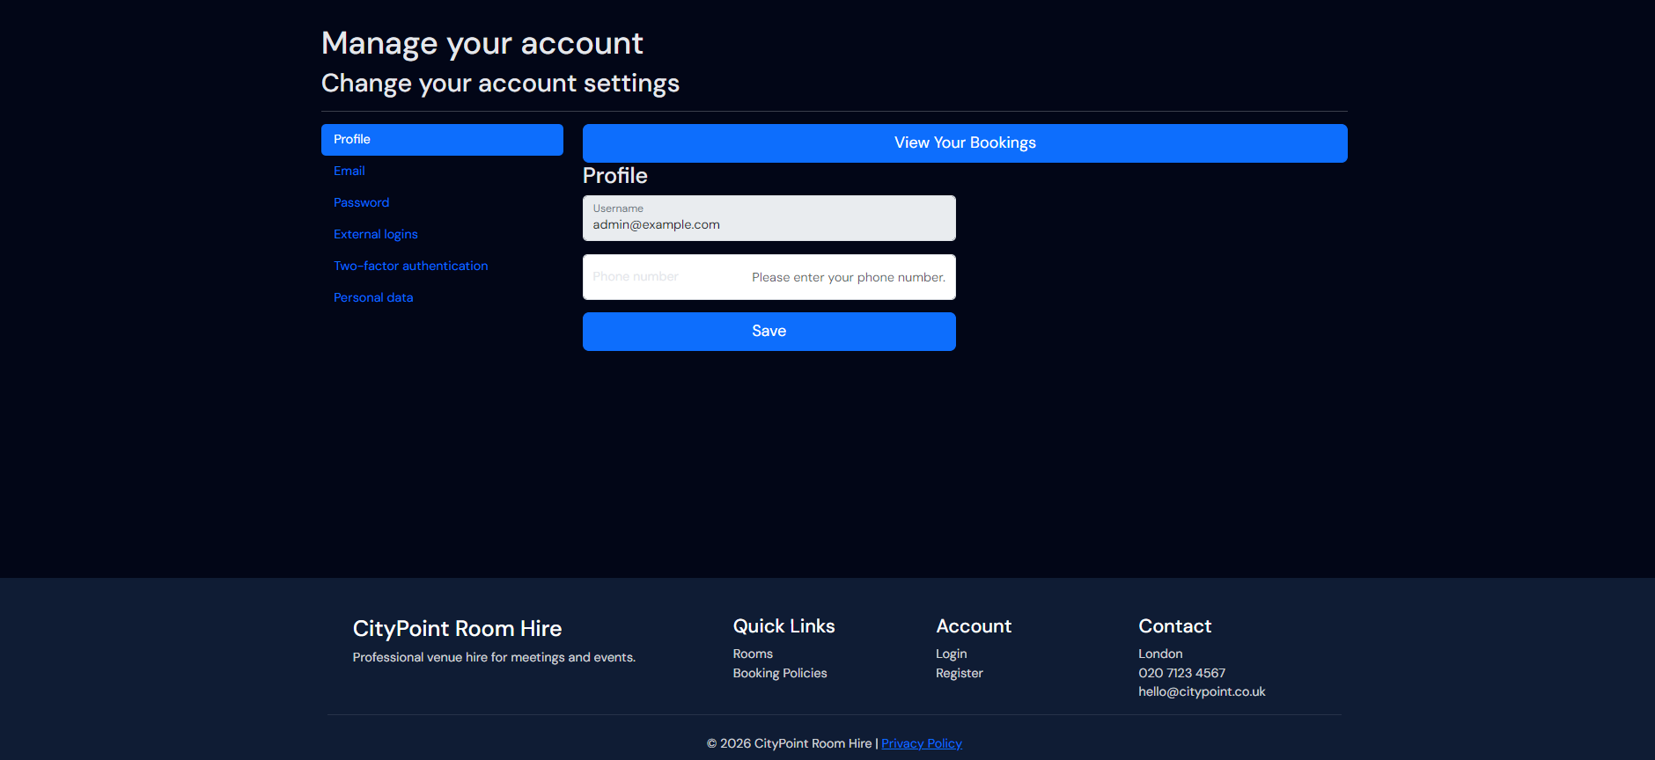

However, to ensure for more accessibility for a larger range of users, we should also add a high contrast mode so that everbody can make use of the website. I added the following code to the site.css:

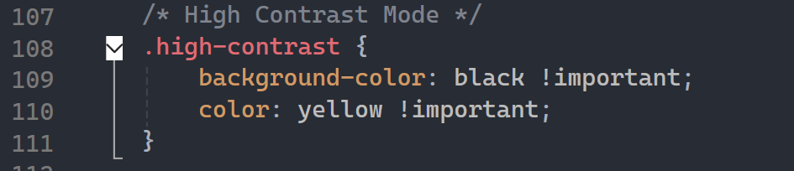

This follows common high contrast mode colours schemes and fits the website. I then added the function the accessibility.js file:

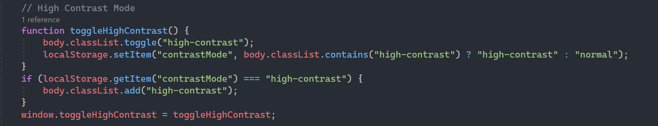

I then added the button:



It was working once again, but not how I wanted it to, so I added extra css to make it look better and apply for all contents of the page:

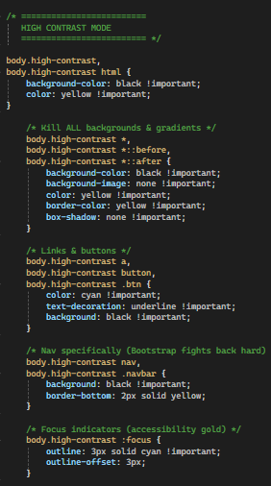

Once doing this, the high contrast mode setting was working just fine, once toggled on it looks as so:

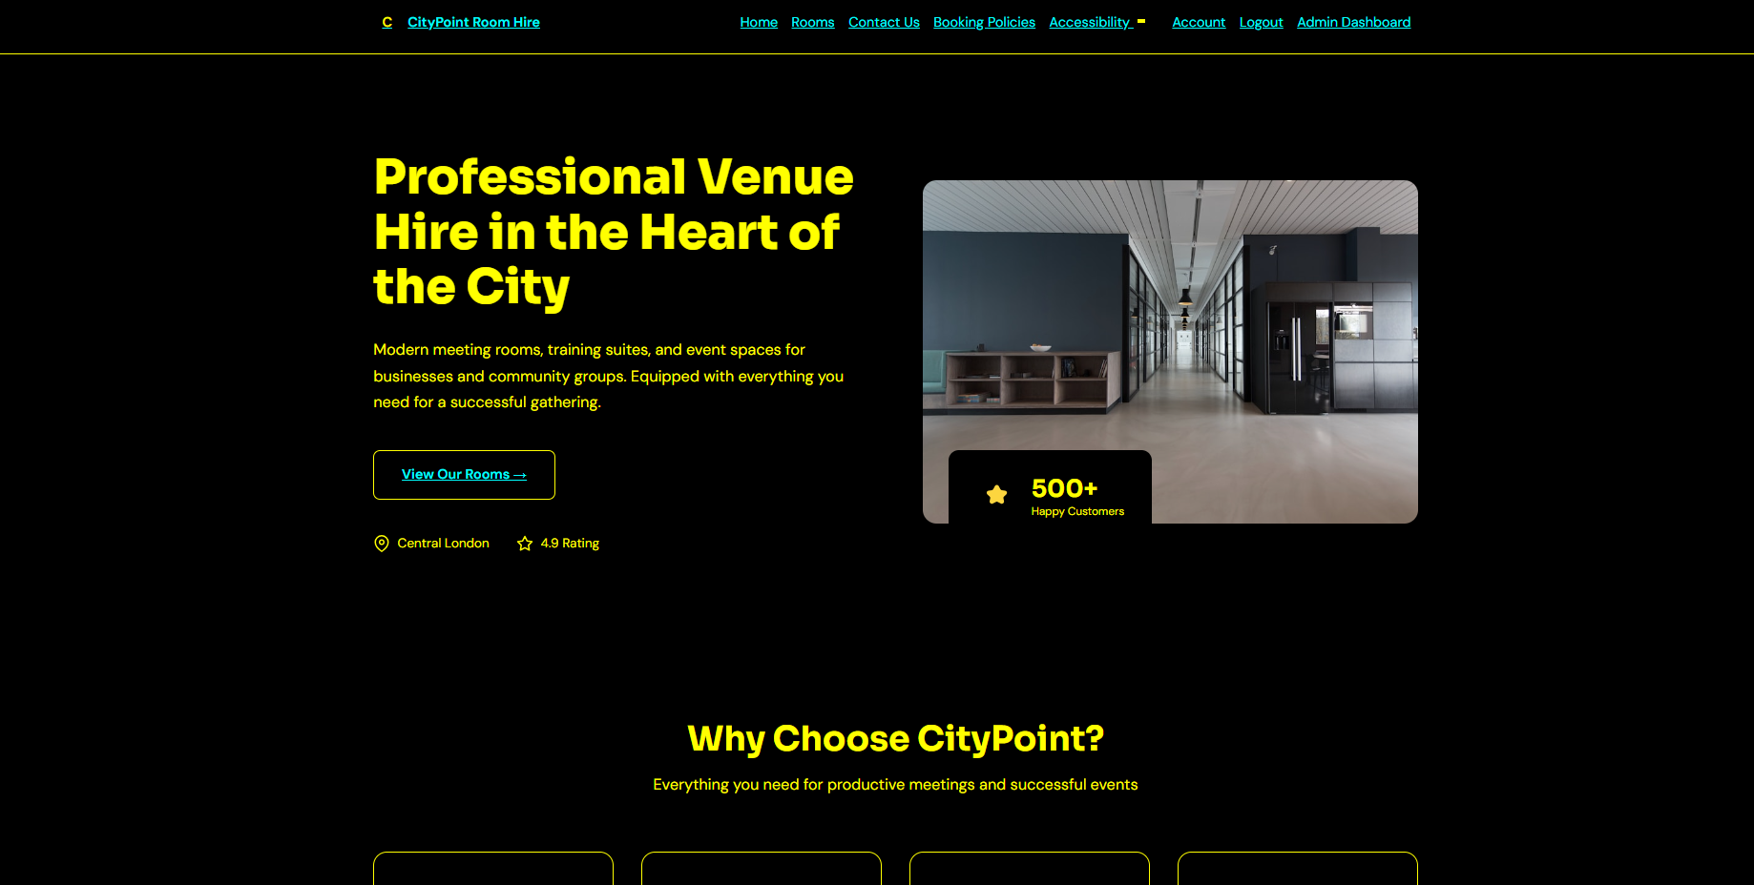

However, adjustable font sizes is also industry standard to ensure that your website is more accessible to those with visual impairments.

I added the following code to the accessibility.js file to make font sizes adjustable from lower to higher:

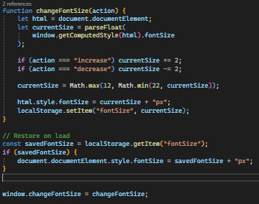

It also saves font sizes when you go across pages. I then added this to the layout file:



Now font sizes are adjustable just how I wanted. Here is the increased font size (button pressed once from default):

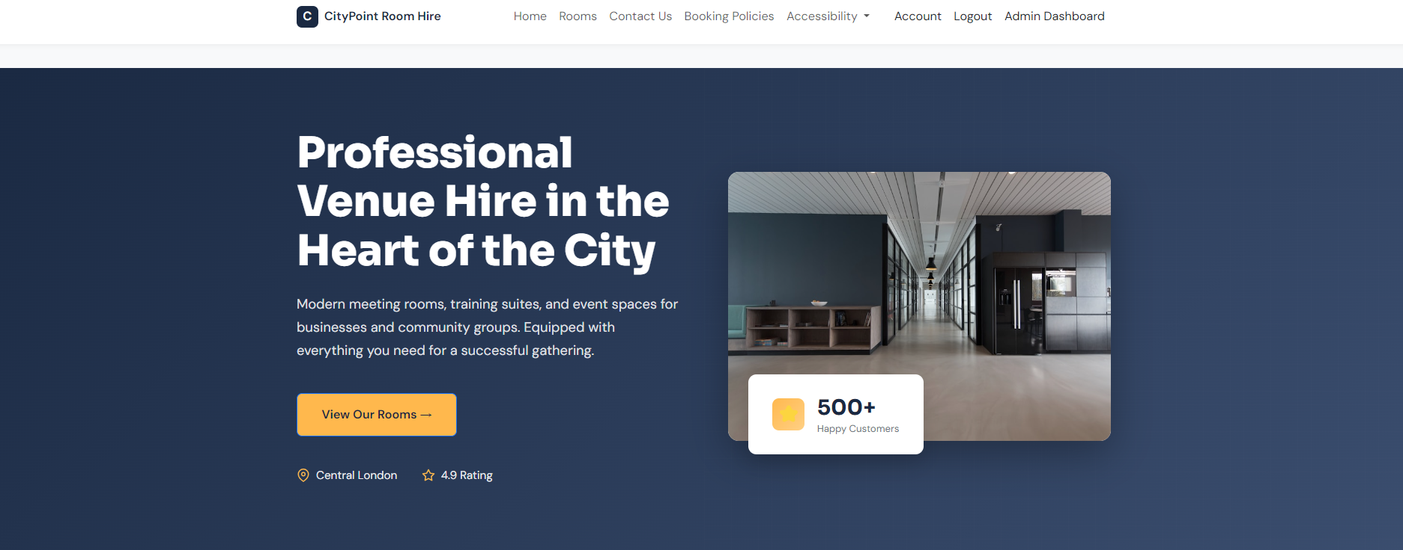

Here is decreased font size (button pressed once from default):

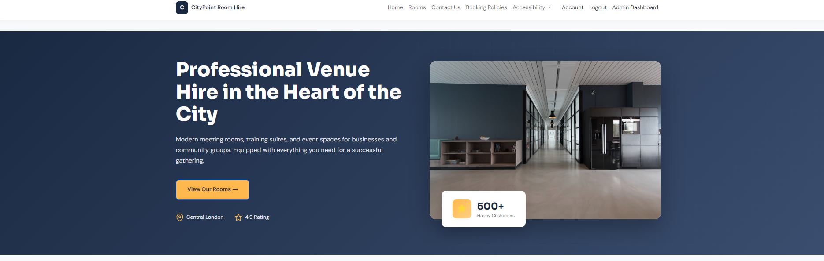

Finally, I believe another accessibility setting which we should implement to reach a larger audience and to comply with legislations is a text to speech feature. I added the following code the accessibility.js to do so:

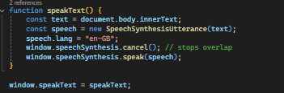

This scans text body and uses an English AI voice to read it, as CItyPoint Room Hire seems to be an English based company. I then added the button to the layout:



Upon clicking the button, page contents are successfully read aloud with no errors. This is how all of the buttons look once stylized.

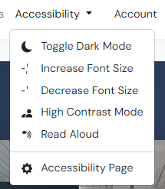

# Version 1.9.4 Booking Overlapping

Right now, we have availability checks but not a check if booking times/dates overlap. To do this, you can implement code into the post create in the booking controller to check for overlapping bookings for same room and date.

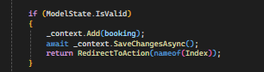

So, I changed this code to the following:

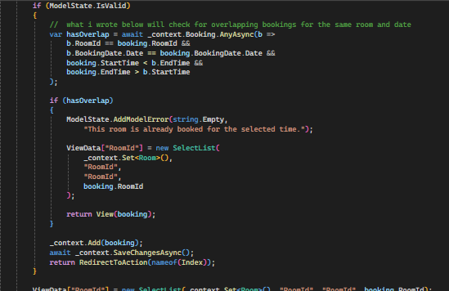

This creates a variable which scans the database and gets the roomId and the roomId of that specific bookings alongside dates and times, and if there is an overlap it will give the user an error. Testing this on the webpage when making a booking. However, I realized that pending bookings should not be counted as the system could be bruteforced or simply overloaded with a bunch of pending bookings, making the booking system unusable. For that reason, I added the following code:

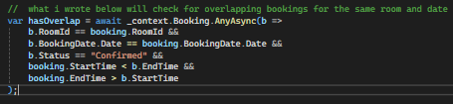

Now it is working, I have a booking and I cannot replicate it as it is a confirmed booking. I cannot order in that time slot now.



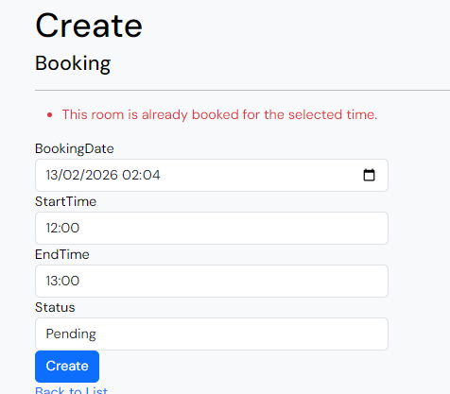

However, the roomId in the url was no longer linked so I changed a bit of the logic of the code

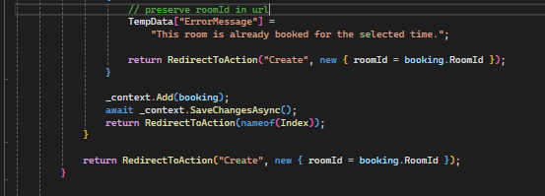

Now there are no errors.

# Version 1.9.5 – Non existent booking dates

Currently, you can book non existent booking dates. This is simply fixed through this block of code:

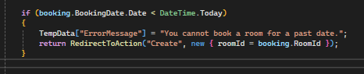

This scans the booking date and compares it to the date of today, and will provide a temporary error message if it is. Upon testing, it works.

